**Statistics 6610**

**Surabhi asati**

**Project 1:**

1. Produce new versions of the visualization from questions 2. 3. and 5. From the Midterm.

* Here is the link to the USGS website where the worldwide [earthquake](https://earthquake.usgs.gov/earthquakes/feed/v1.0/) data can be downloaded. Download the All Earthquakes data for the Past 30 Days in Spreedsheet Format. Using Microsoft Excel or Tableau or R make a map of the world with points where the earthquakes occurred. Make a bubble map using the magnitude.

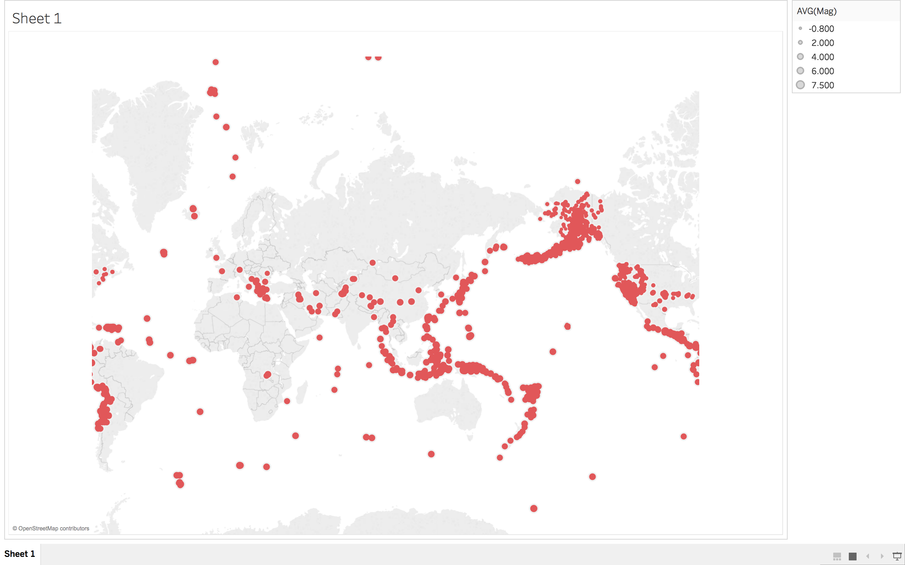

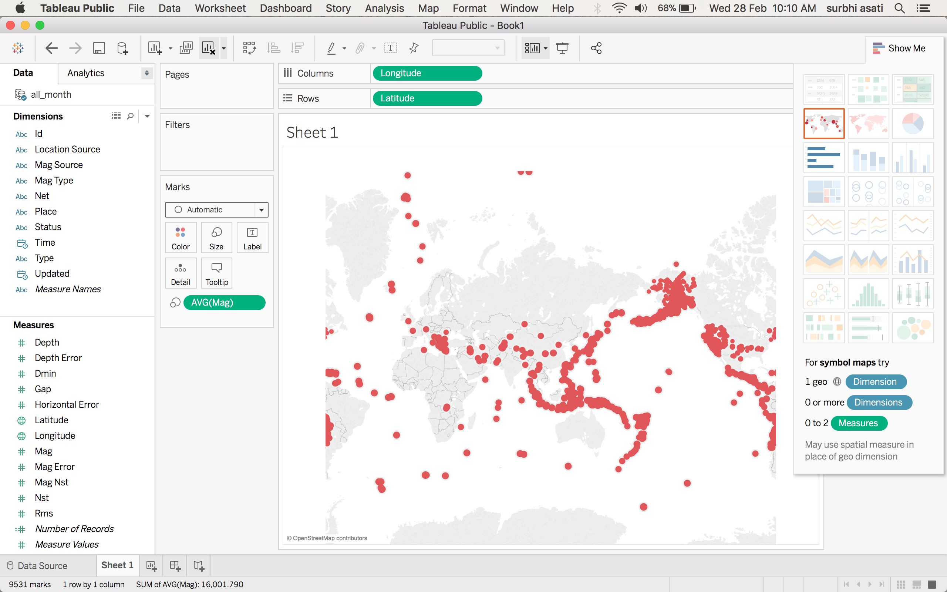

* Here is a link to the [dials](http://viz.wtf/image/163952481793) that Microsoft presentes when Microsoft Edge is stated. What do you think about using **dials** as a visualization? Create a spreadsheet of the data presented. Using either Microsoft Excel or Tableau make an appropriate bar graph. Hint: Make sure the y-axis starts at zero. Comment on how much faster Edge is.

**dials** as a visualization:

Dials provide a real-time count for an indicator however, dial charts cannot contain comparison or historical data. A dial shows a half circle, round meter where the part in which scores are shown is filled out with a color.  Dial charts are a natural fit for dashboard-style interfaces and are also referred to as speedometer charts because of the visual similarity to a car’s speedometer. Dial charts work well for indicating performance or completion thresholds.

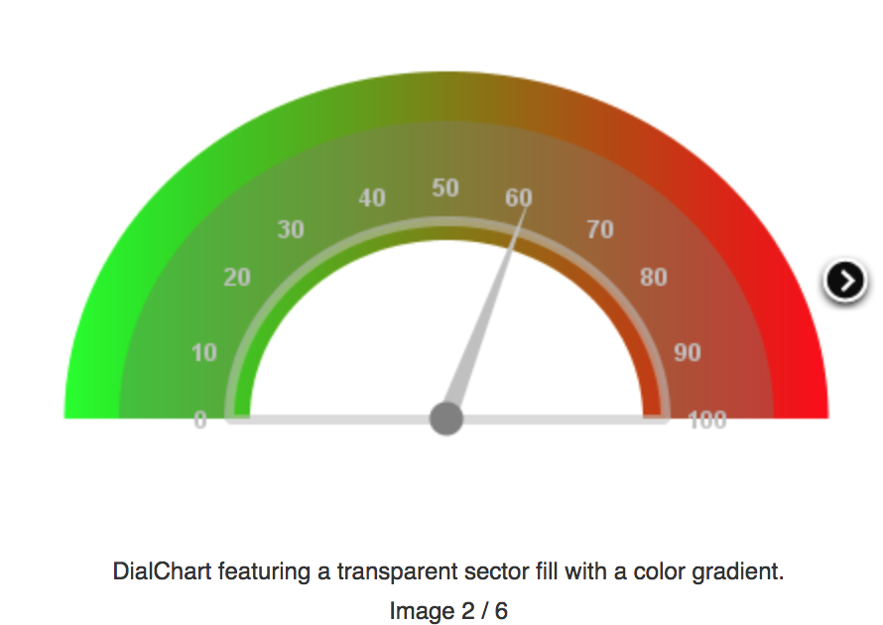

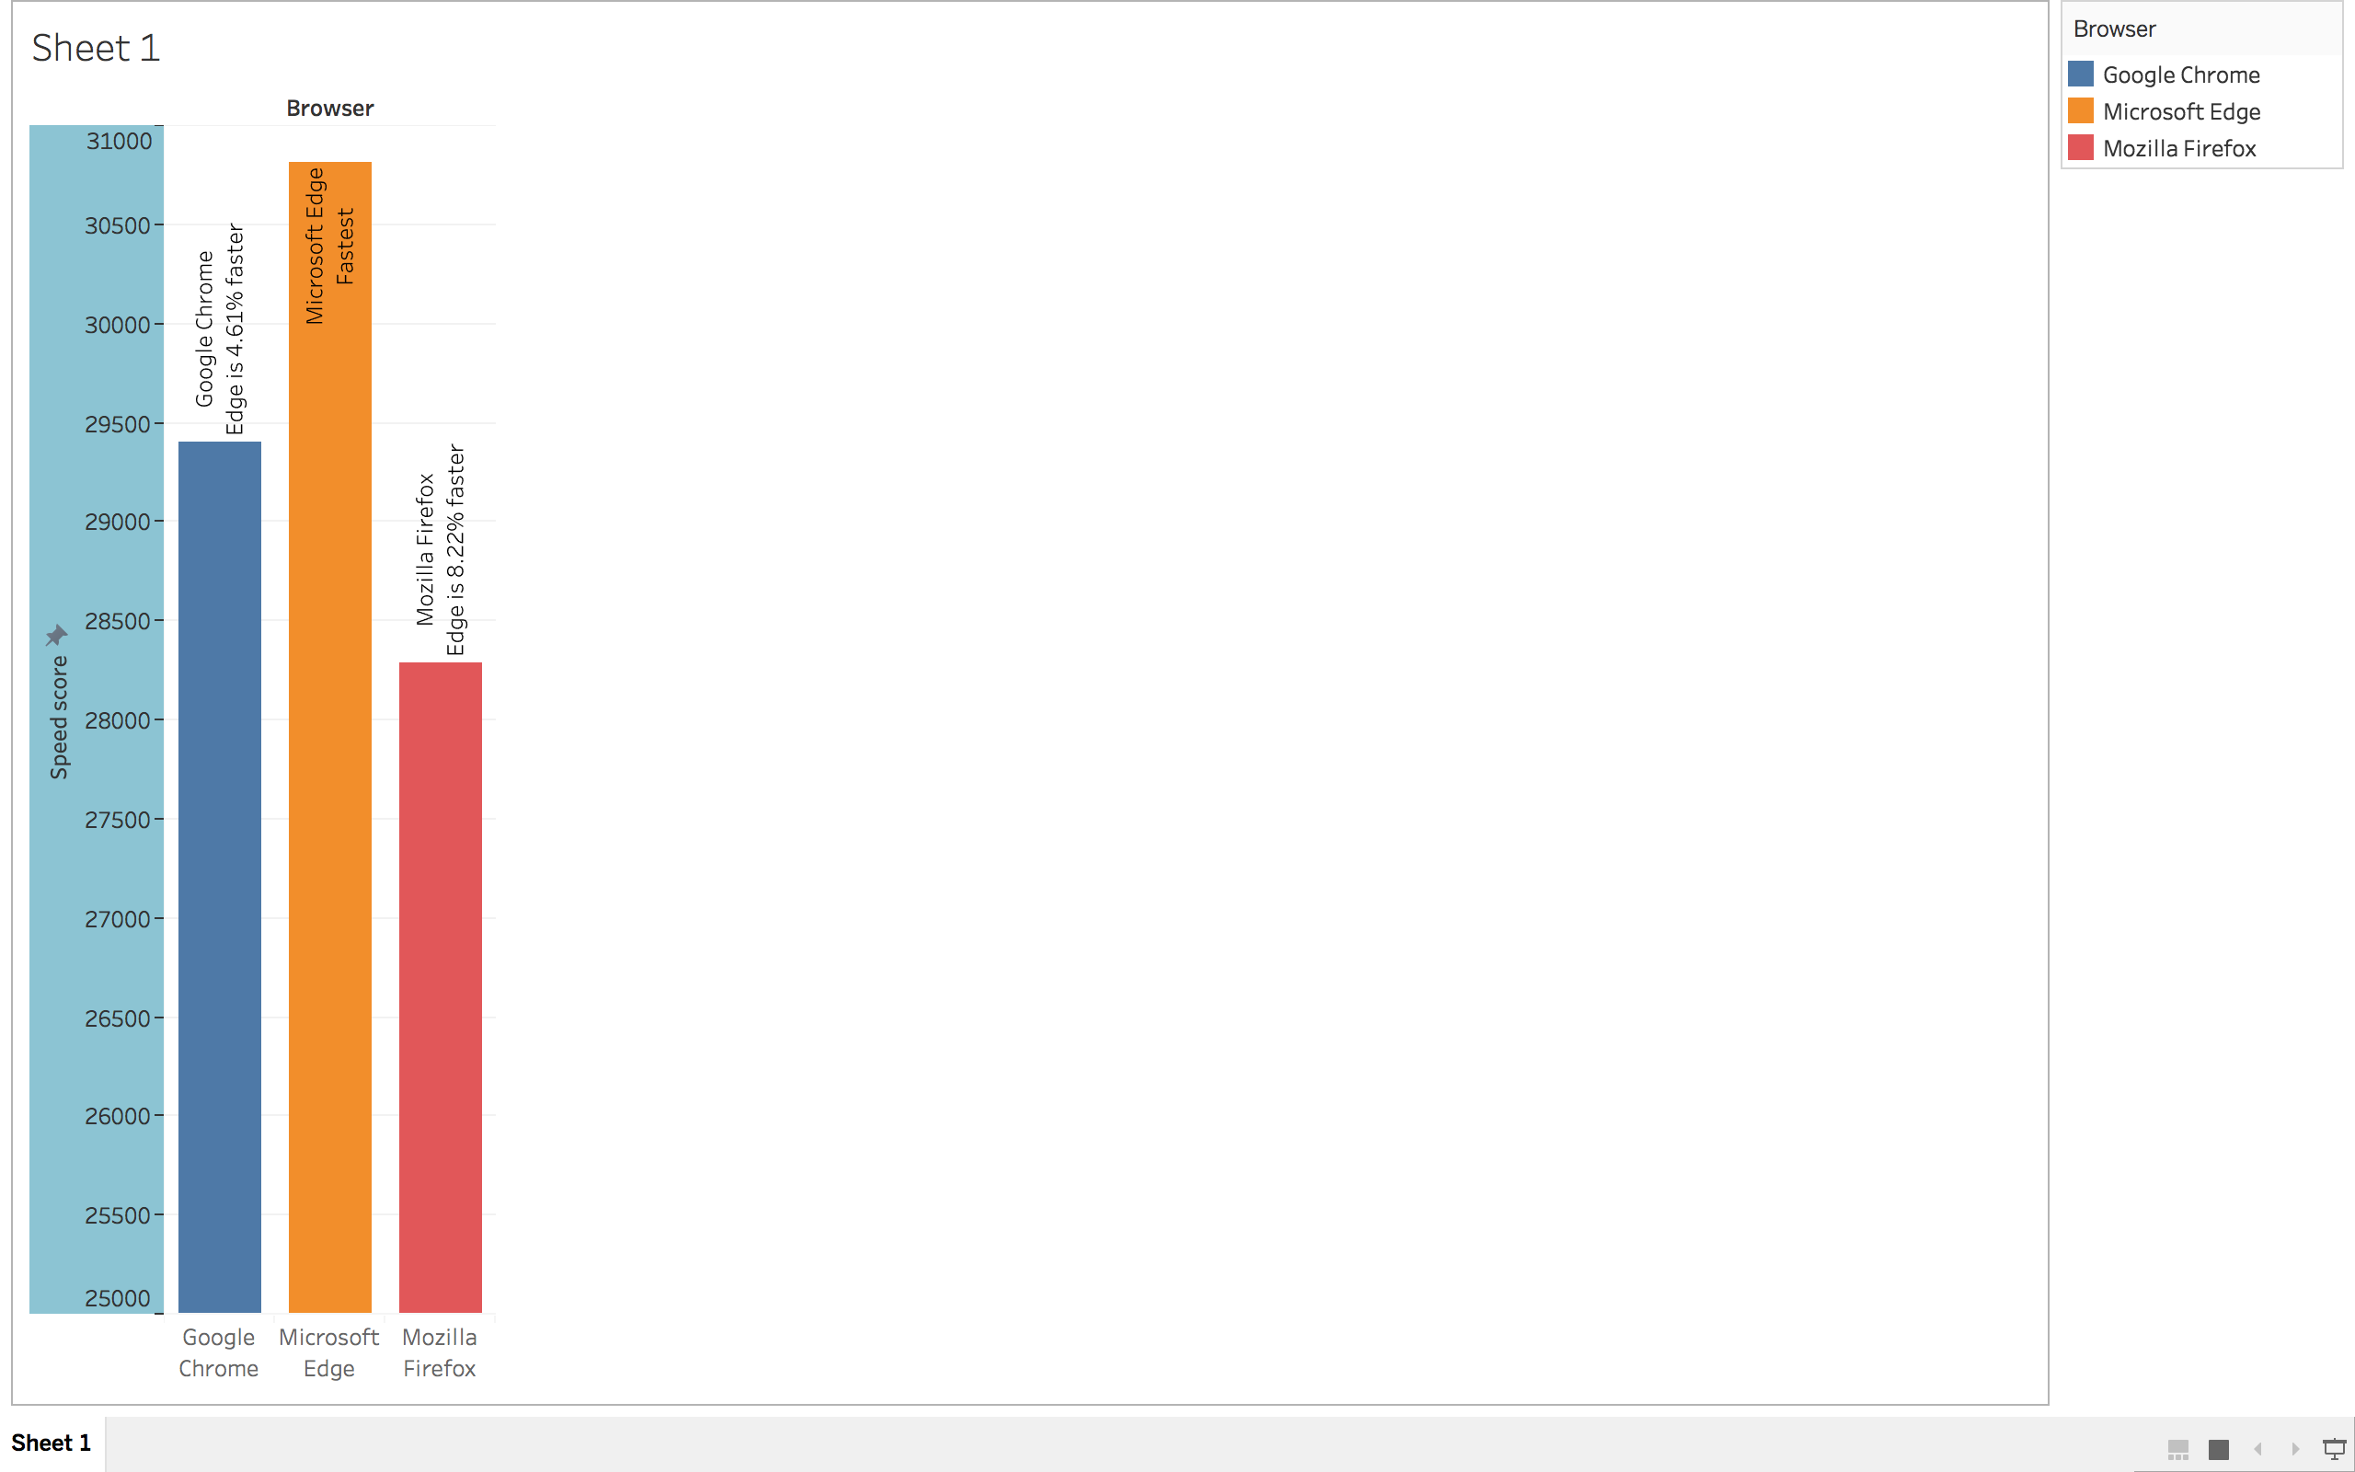

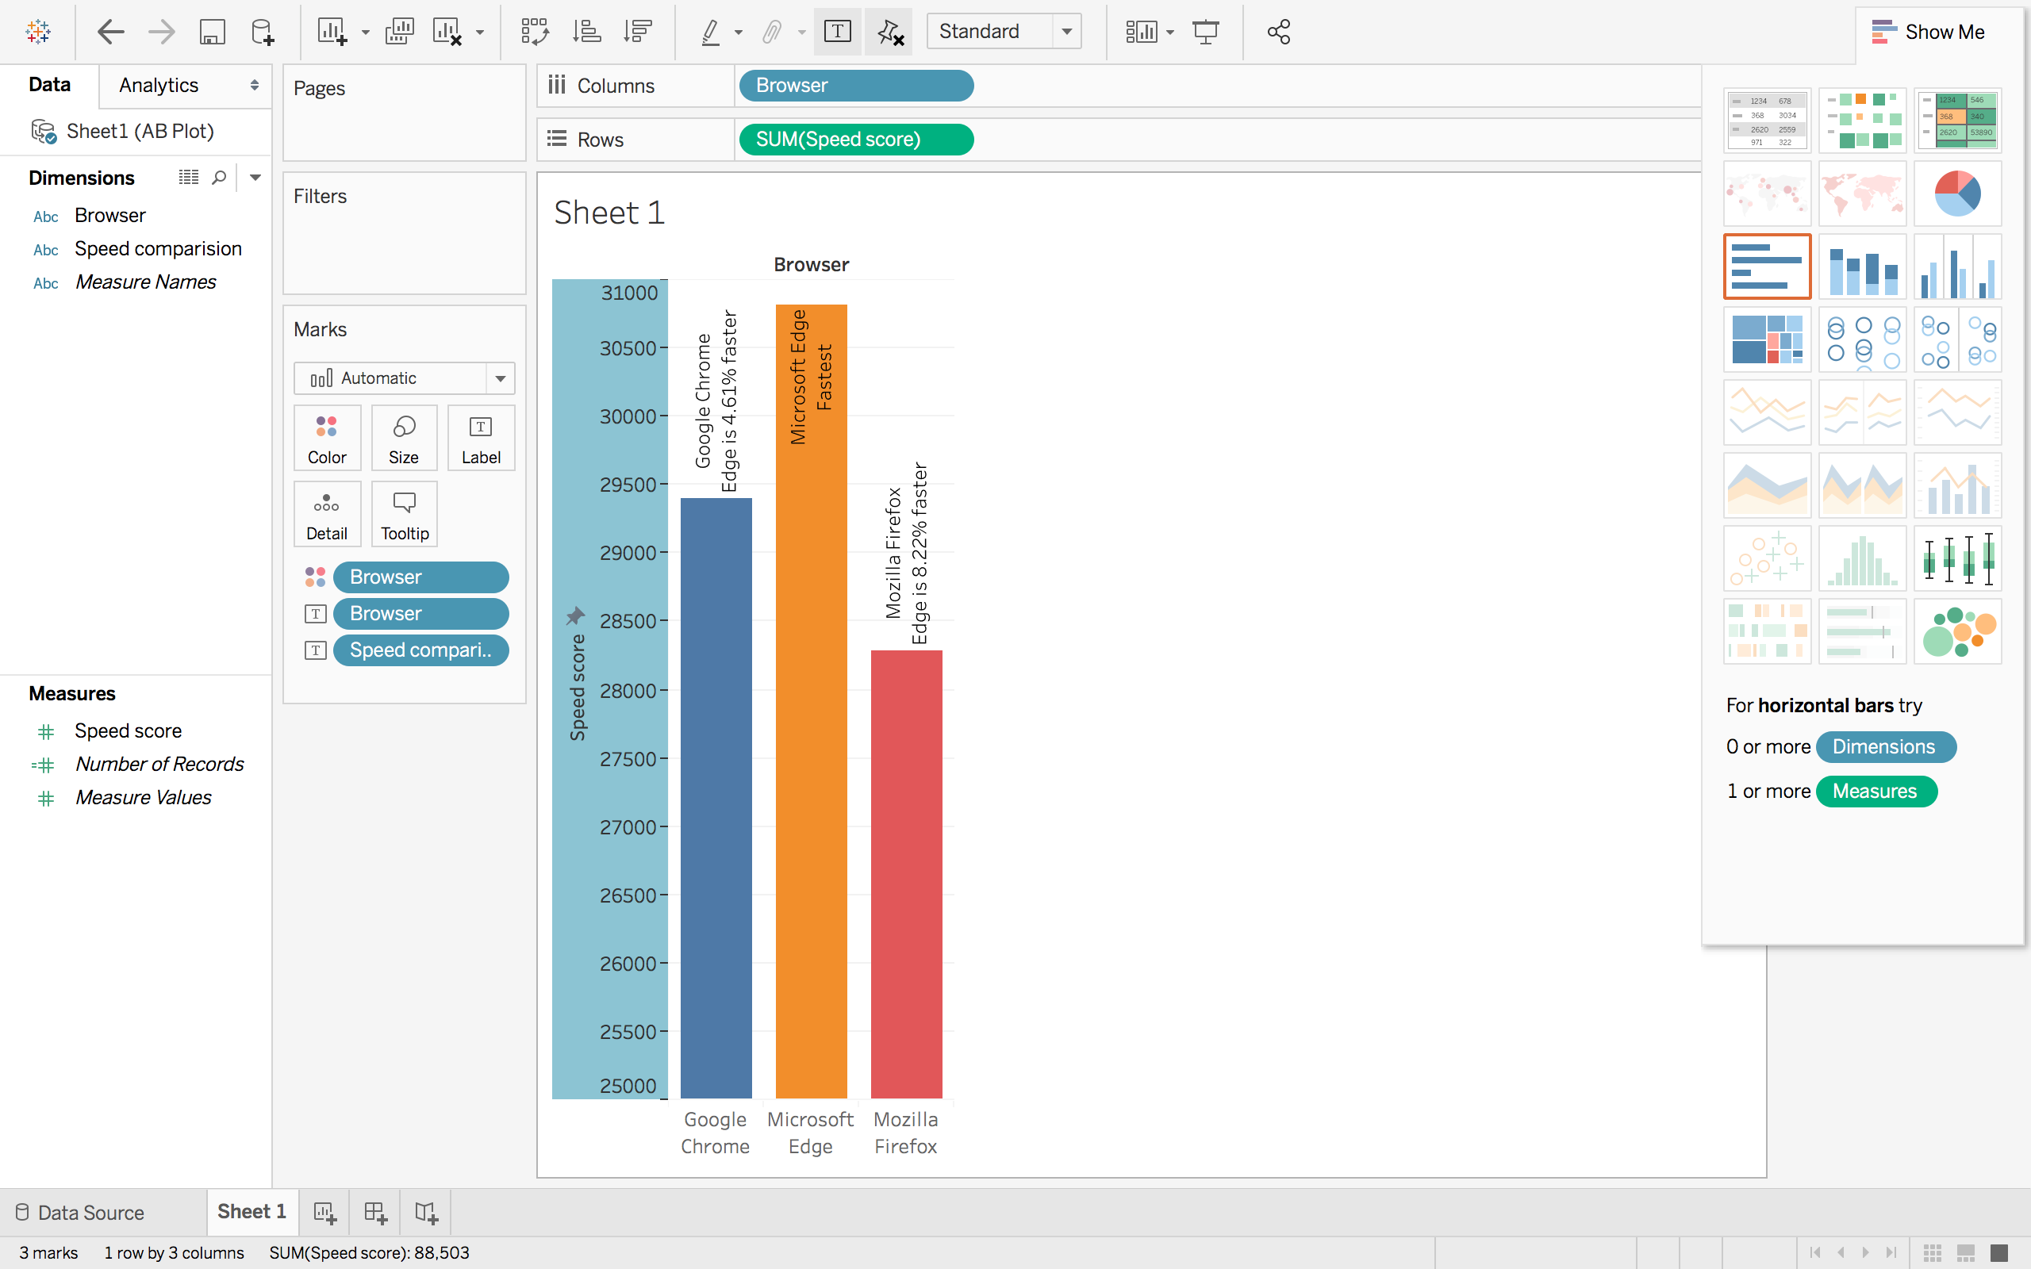

* Here is the link to the [Civilian Unemployment Rate](https://fred.stlouisfed.org/series/UNRATE) data from [FRED](https://fred.stlouisfed.org/). Download the data. Use Microsoft Excel to make the time series plot. Clean the data, save it as a .csv file and load it into Tableau. Make the same time series plot in Tableau and include a forecast in the plot. See Analysis > Forecast.

Time series plot in Excel:

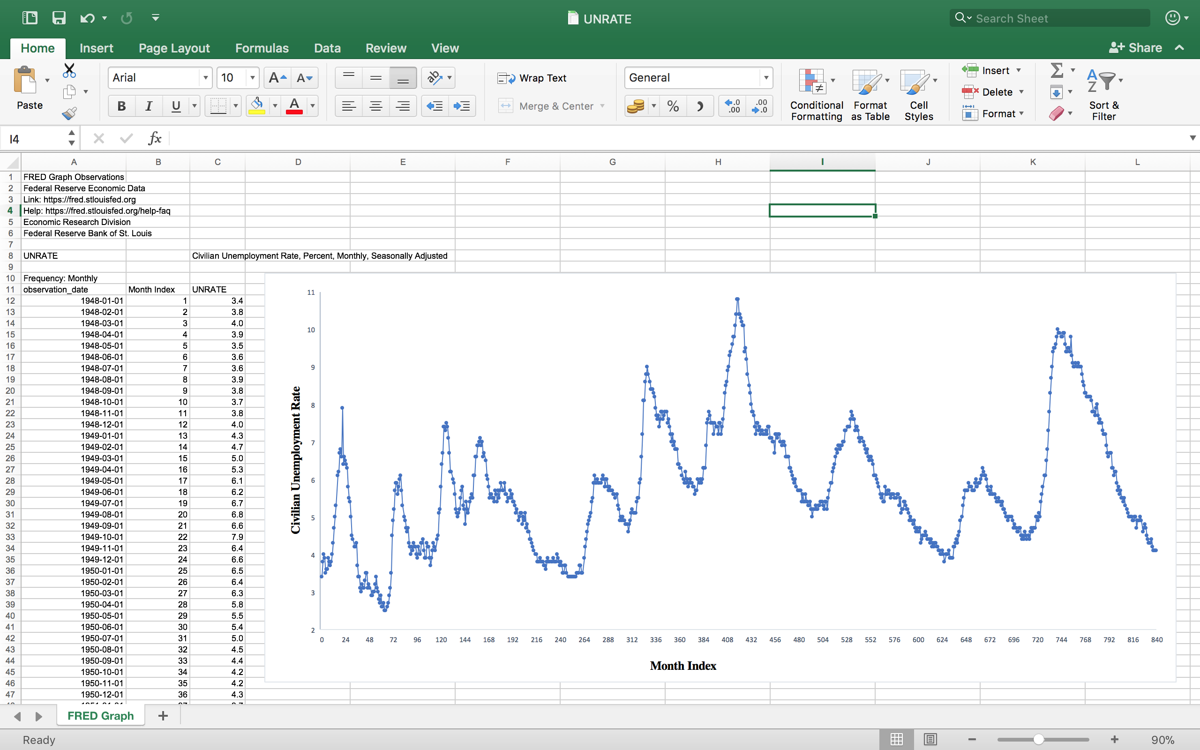

time series plot in Tableau:

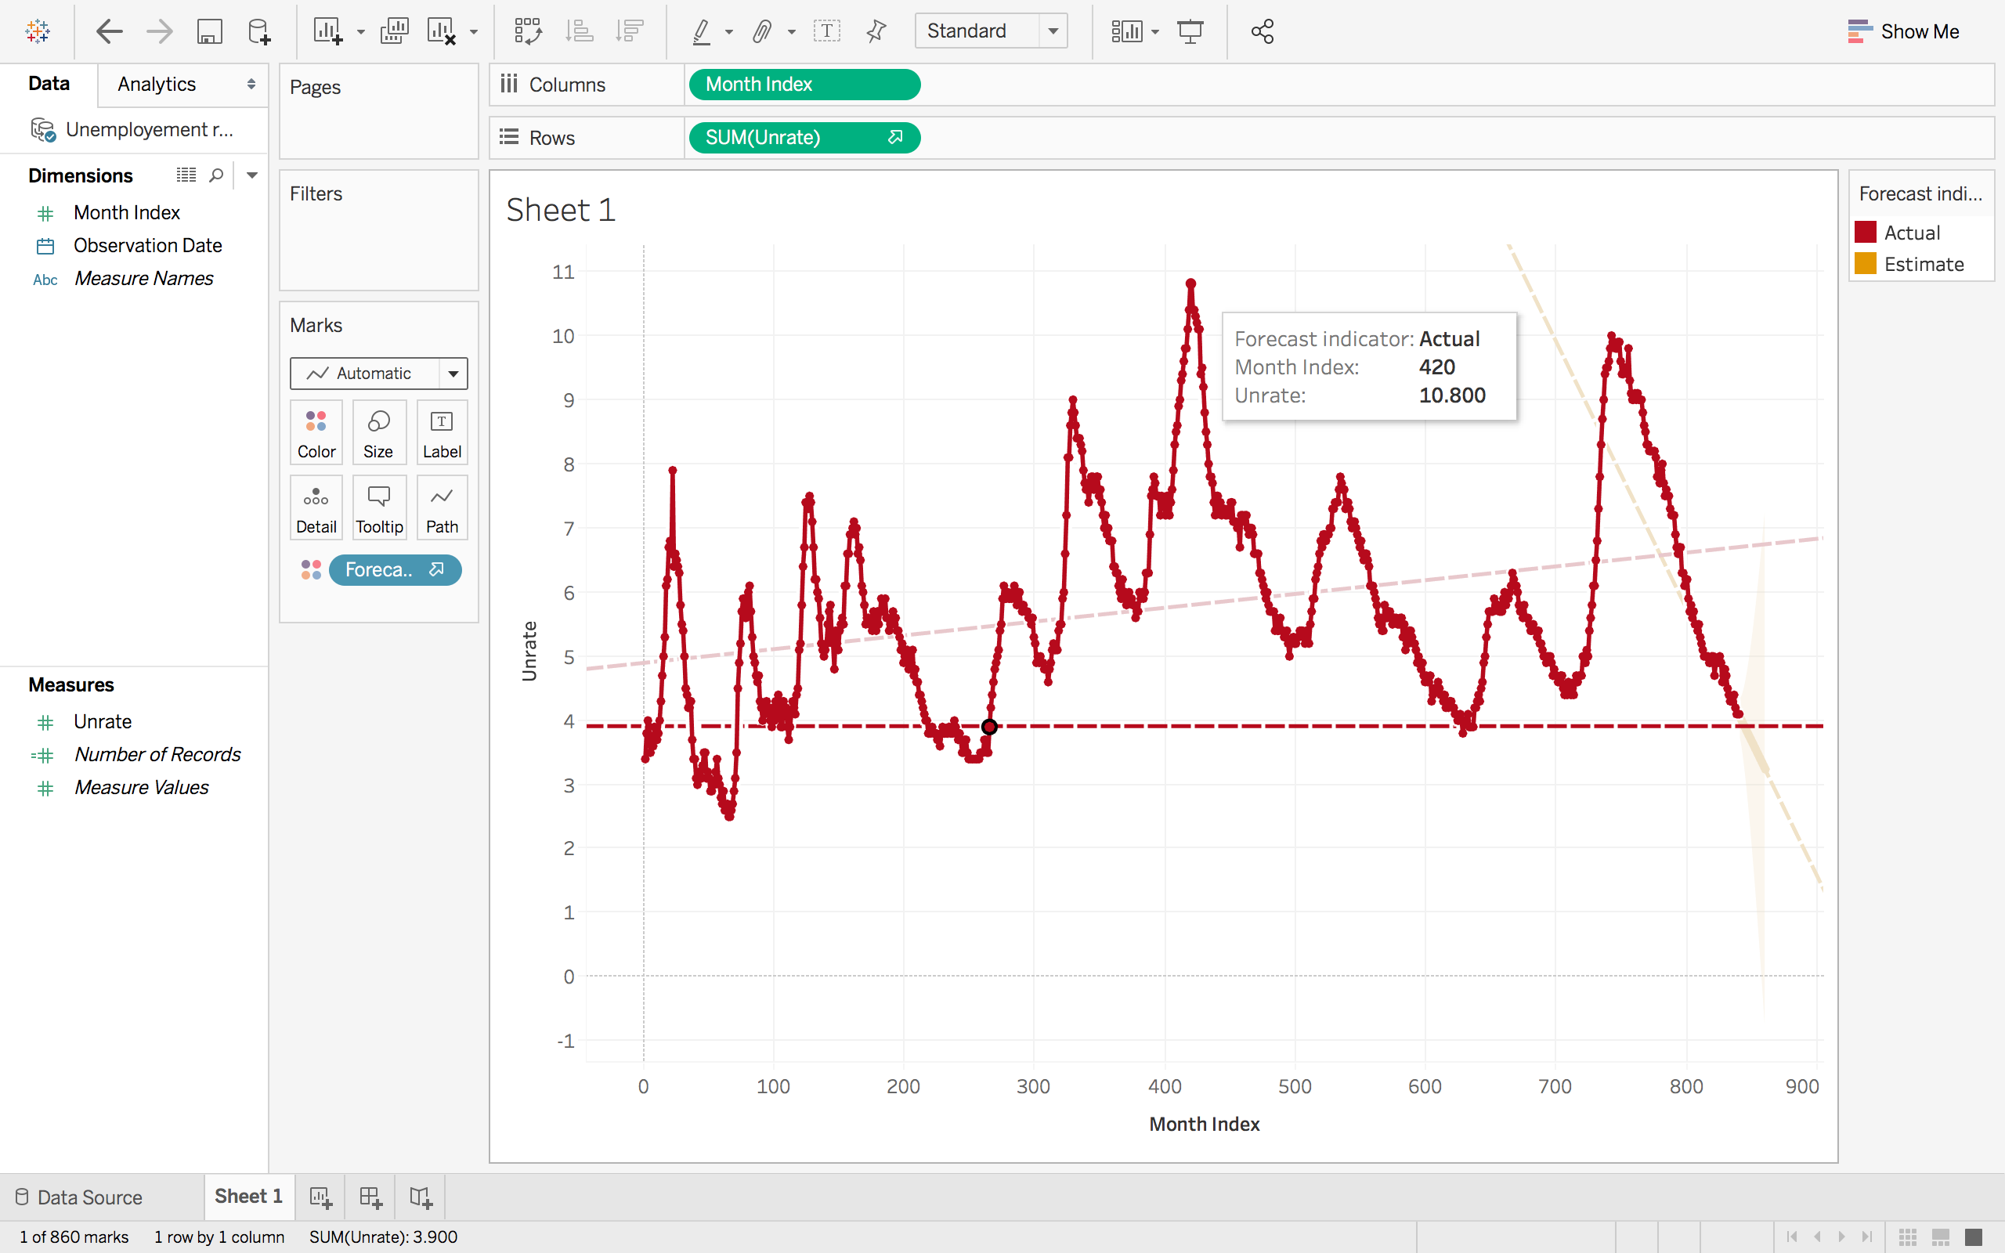

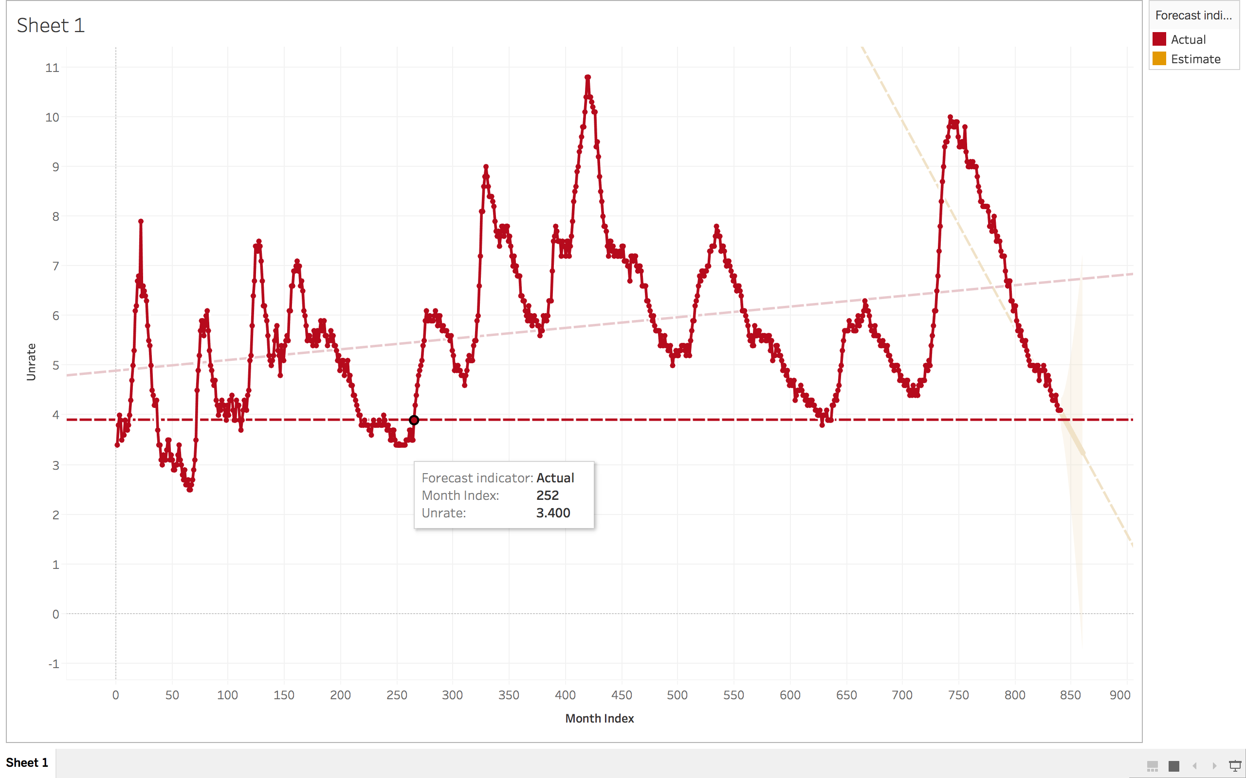

  Make the following plots:

Make a bubble plot for a dataset that included the letters A and B, where the letter A occurs 100 times and the B occurs 50 times.

* Start by creating an Excel spreadsheet containing the data.
* Use Tableau or R to make the visualization.
* Verify that the size of the circles are correct.

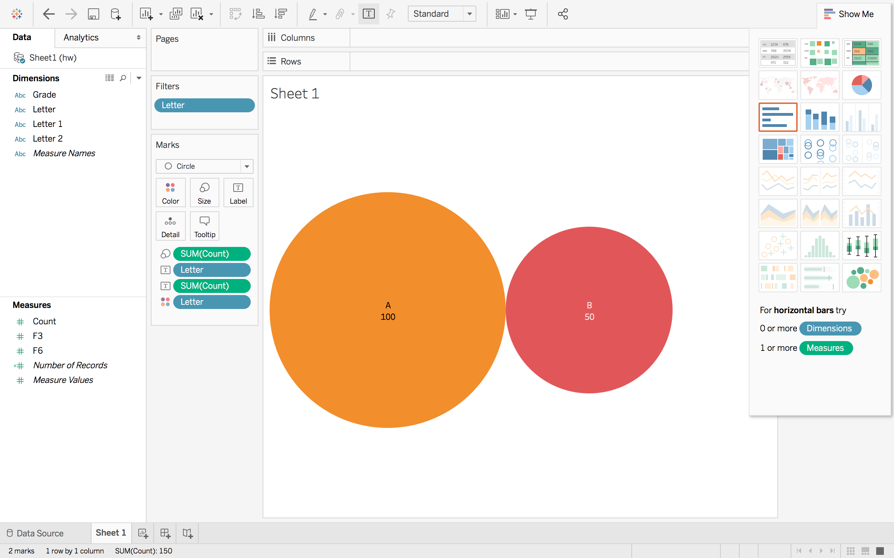

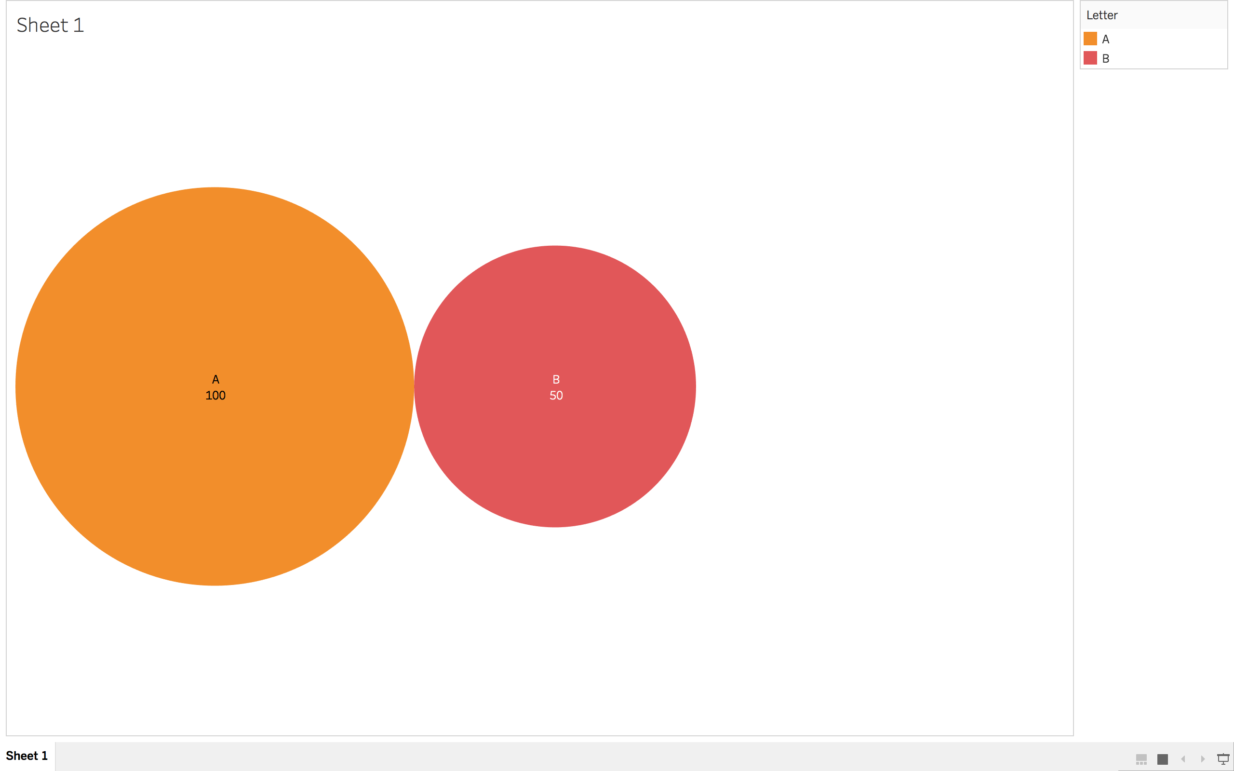

Make a Word Cloud for a dataset that included the letters C and D, where the letter C occurs 300 times and the D occurs 400 times.

* Start by creating an Excel spreadsheet containing the data.
* Use Tableau or R to make the visualization.
* Verify that the size of the font (length time width) are correct.

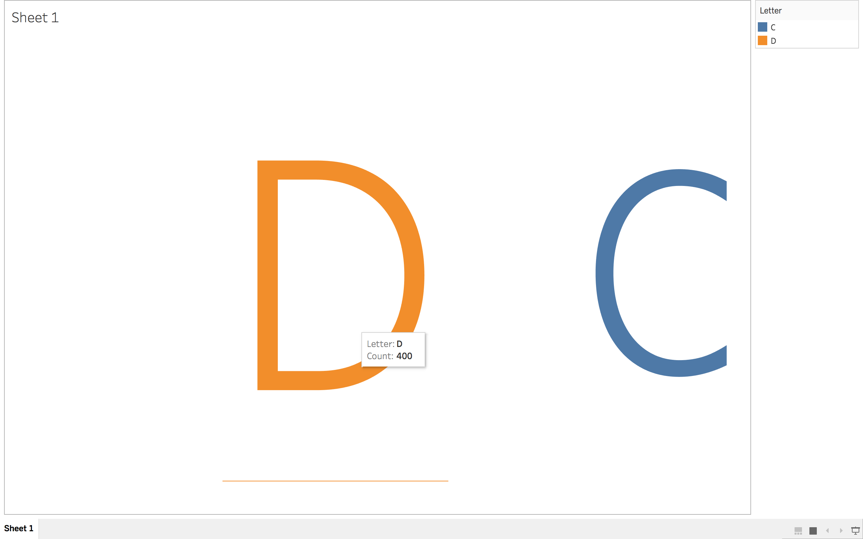

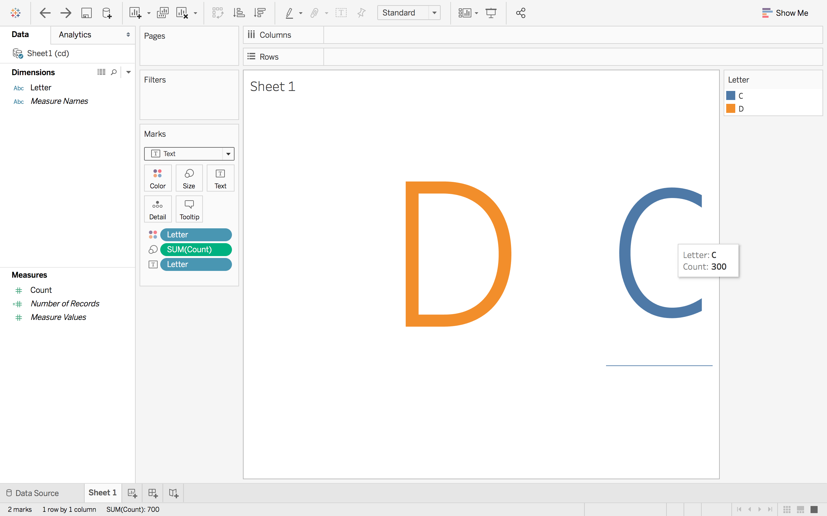

3. Visualize *strike* data in China.

* Use data from the [China Labour Bulletin](http://www.clb.org.hk/) [Strike Map](http://maps.clb.org.hk/strikes/en) website.
* Start by creating an Excel spreadsheet containing the data for each year there is data available for Beijing, Guangdong, Shanghai, and Chongqing. You can read the data off of the map each year. Or you can download the data and use a pivot table by year. Use the following website if needed. [world atlas](http://www.worldatlas.com/aatlas/world.htm)[LATTITUDE AND LONGITUDE FINDER](http://www.worldatlas.com/aatlas/findlatlong.htm)
* Make a time plot for each location using the same scales for the axes. (Use Tableau or R)

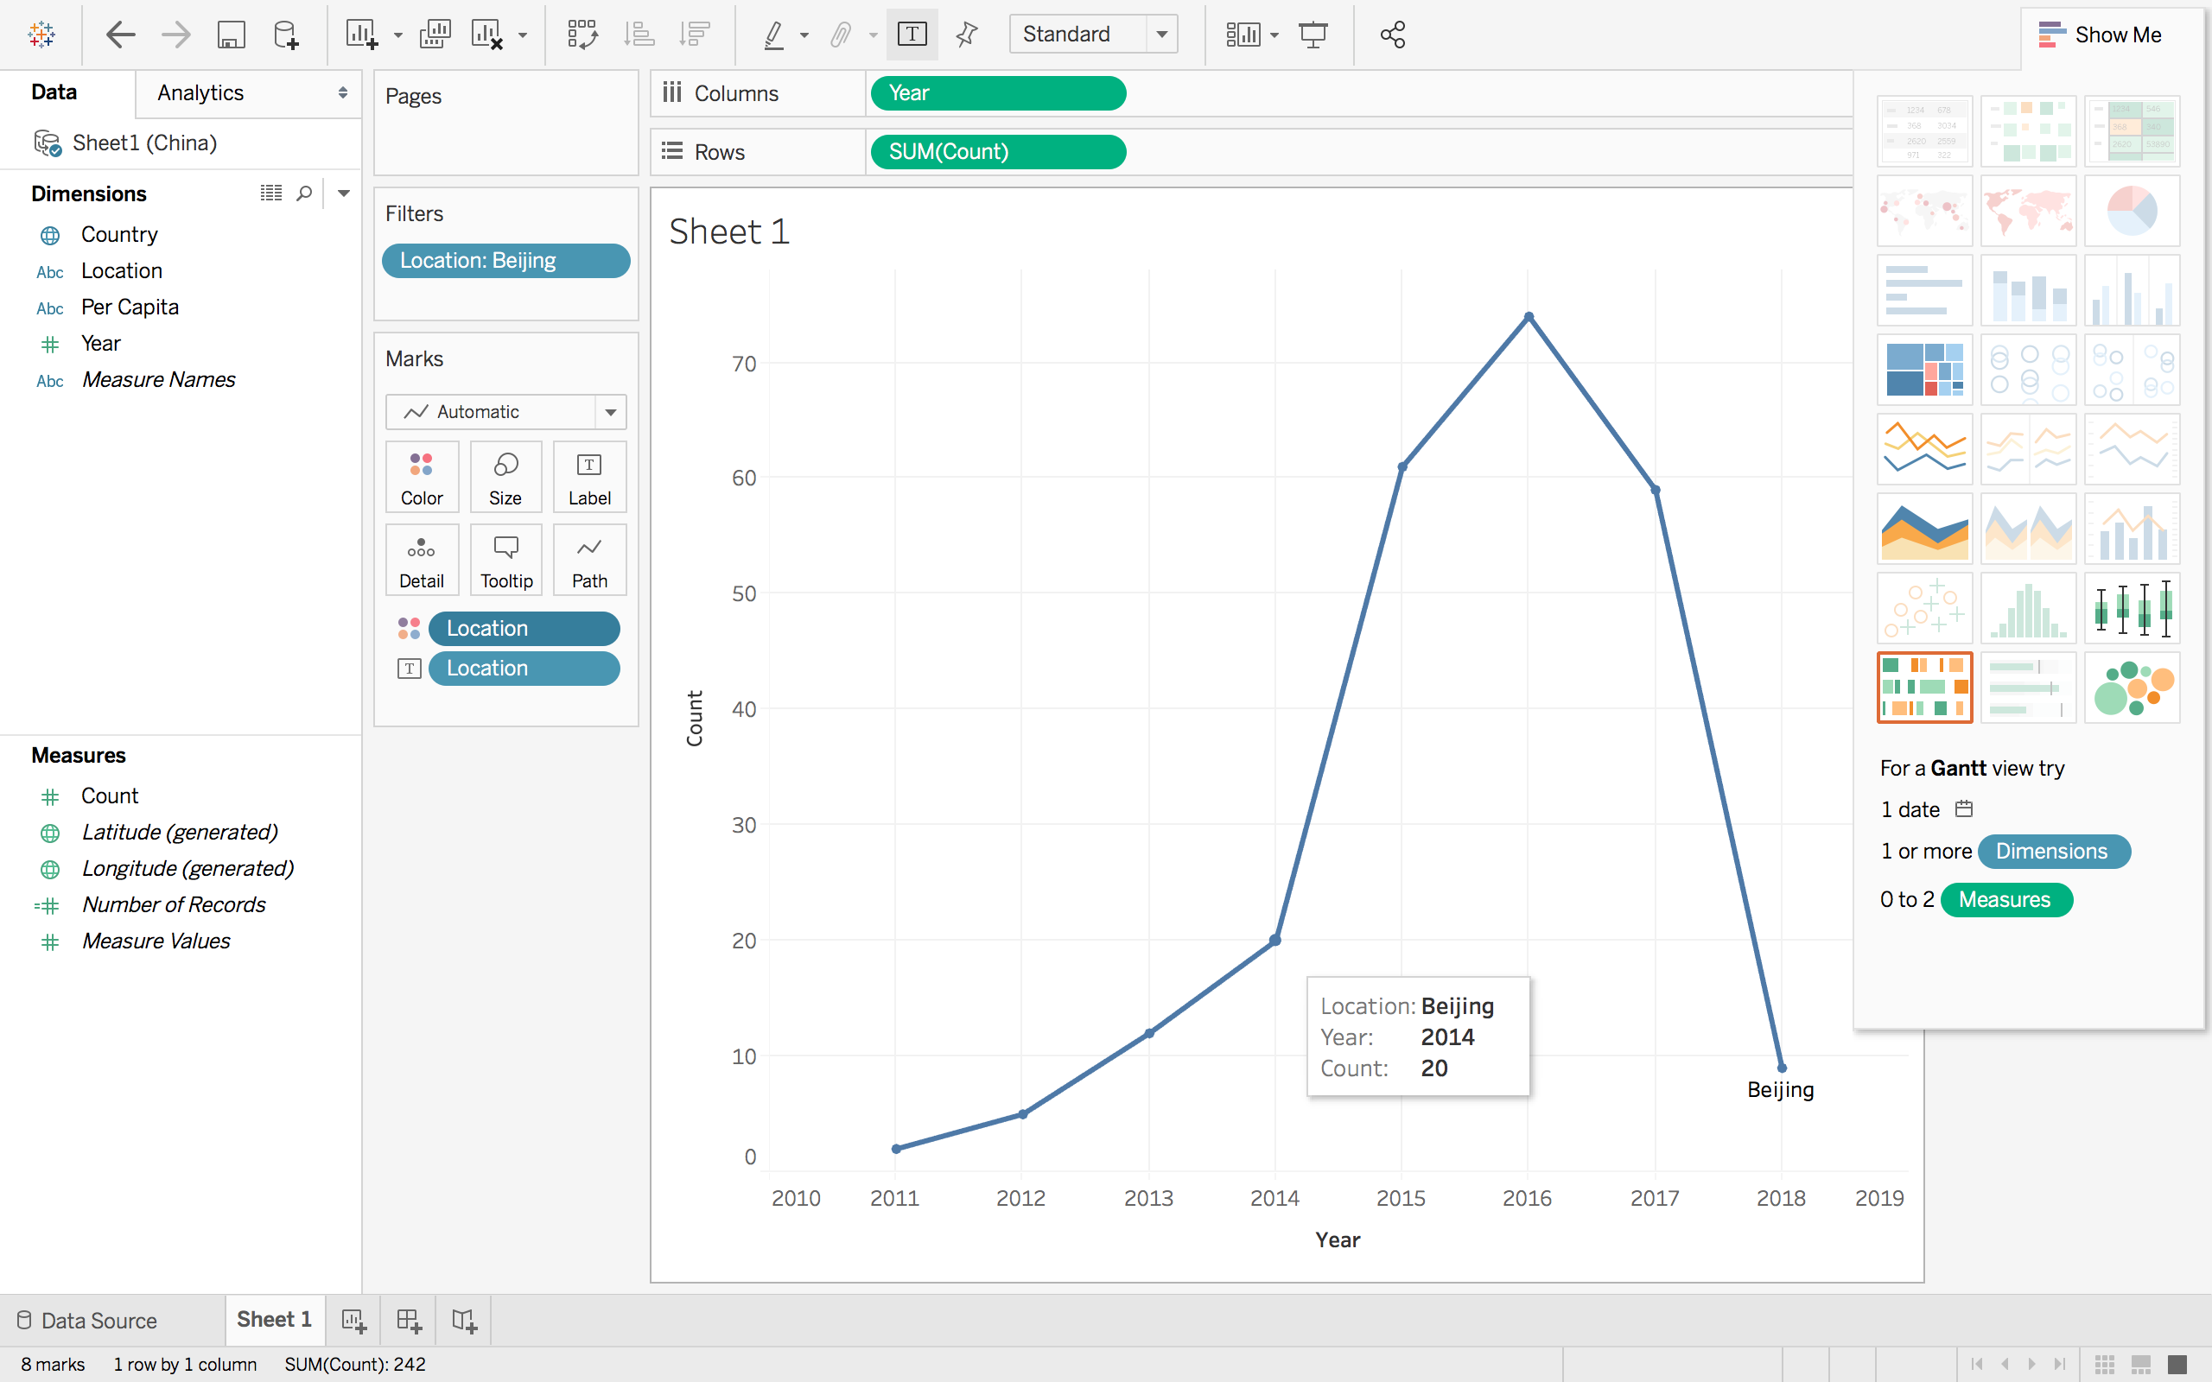

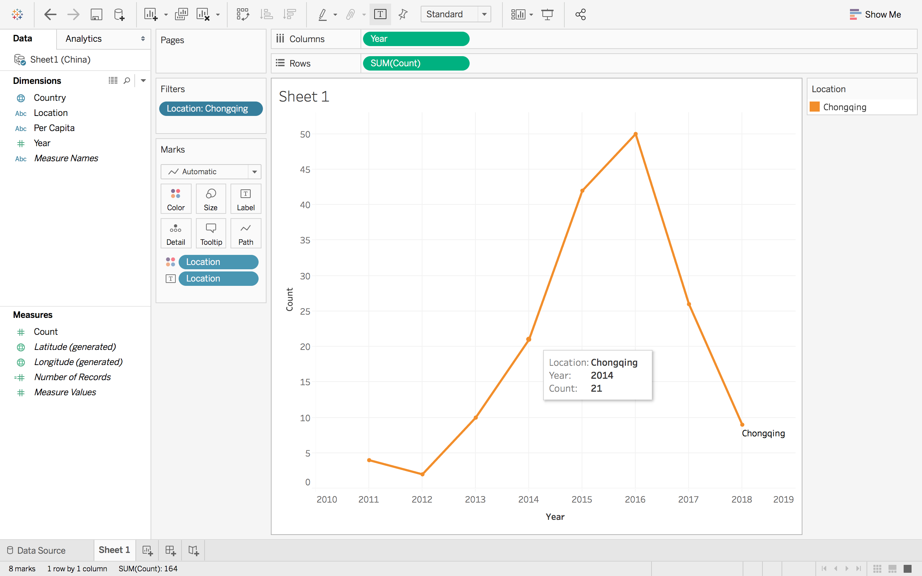

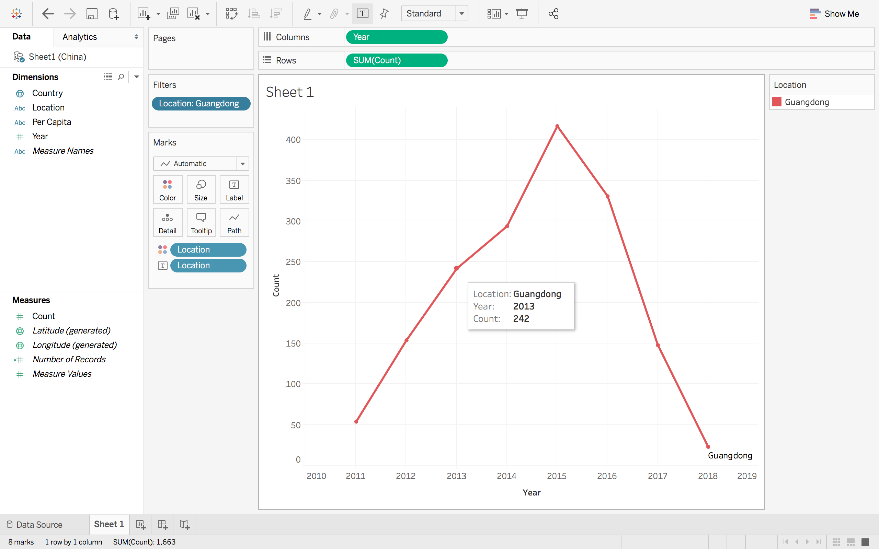

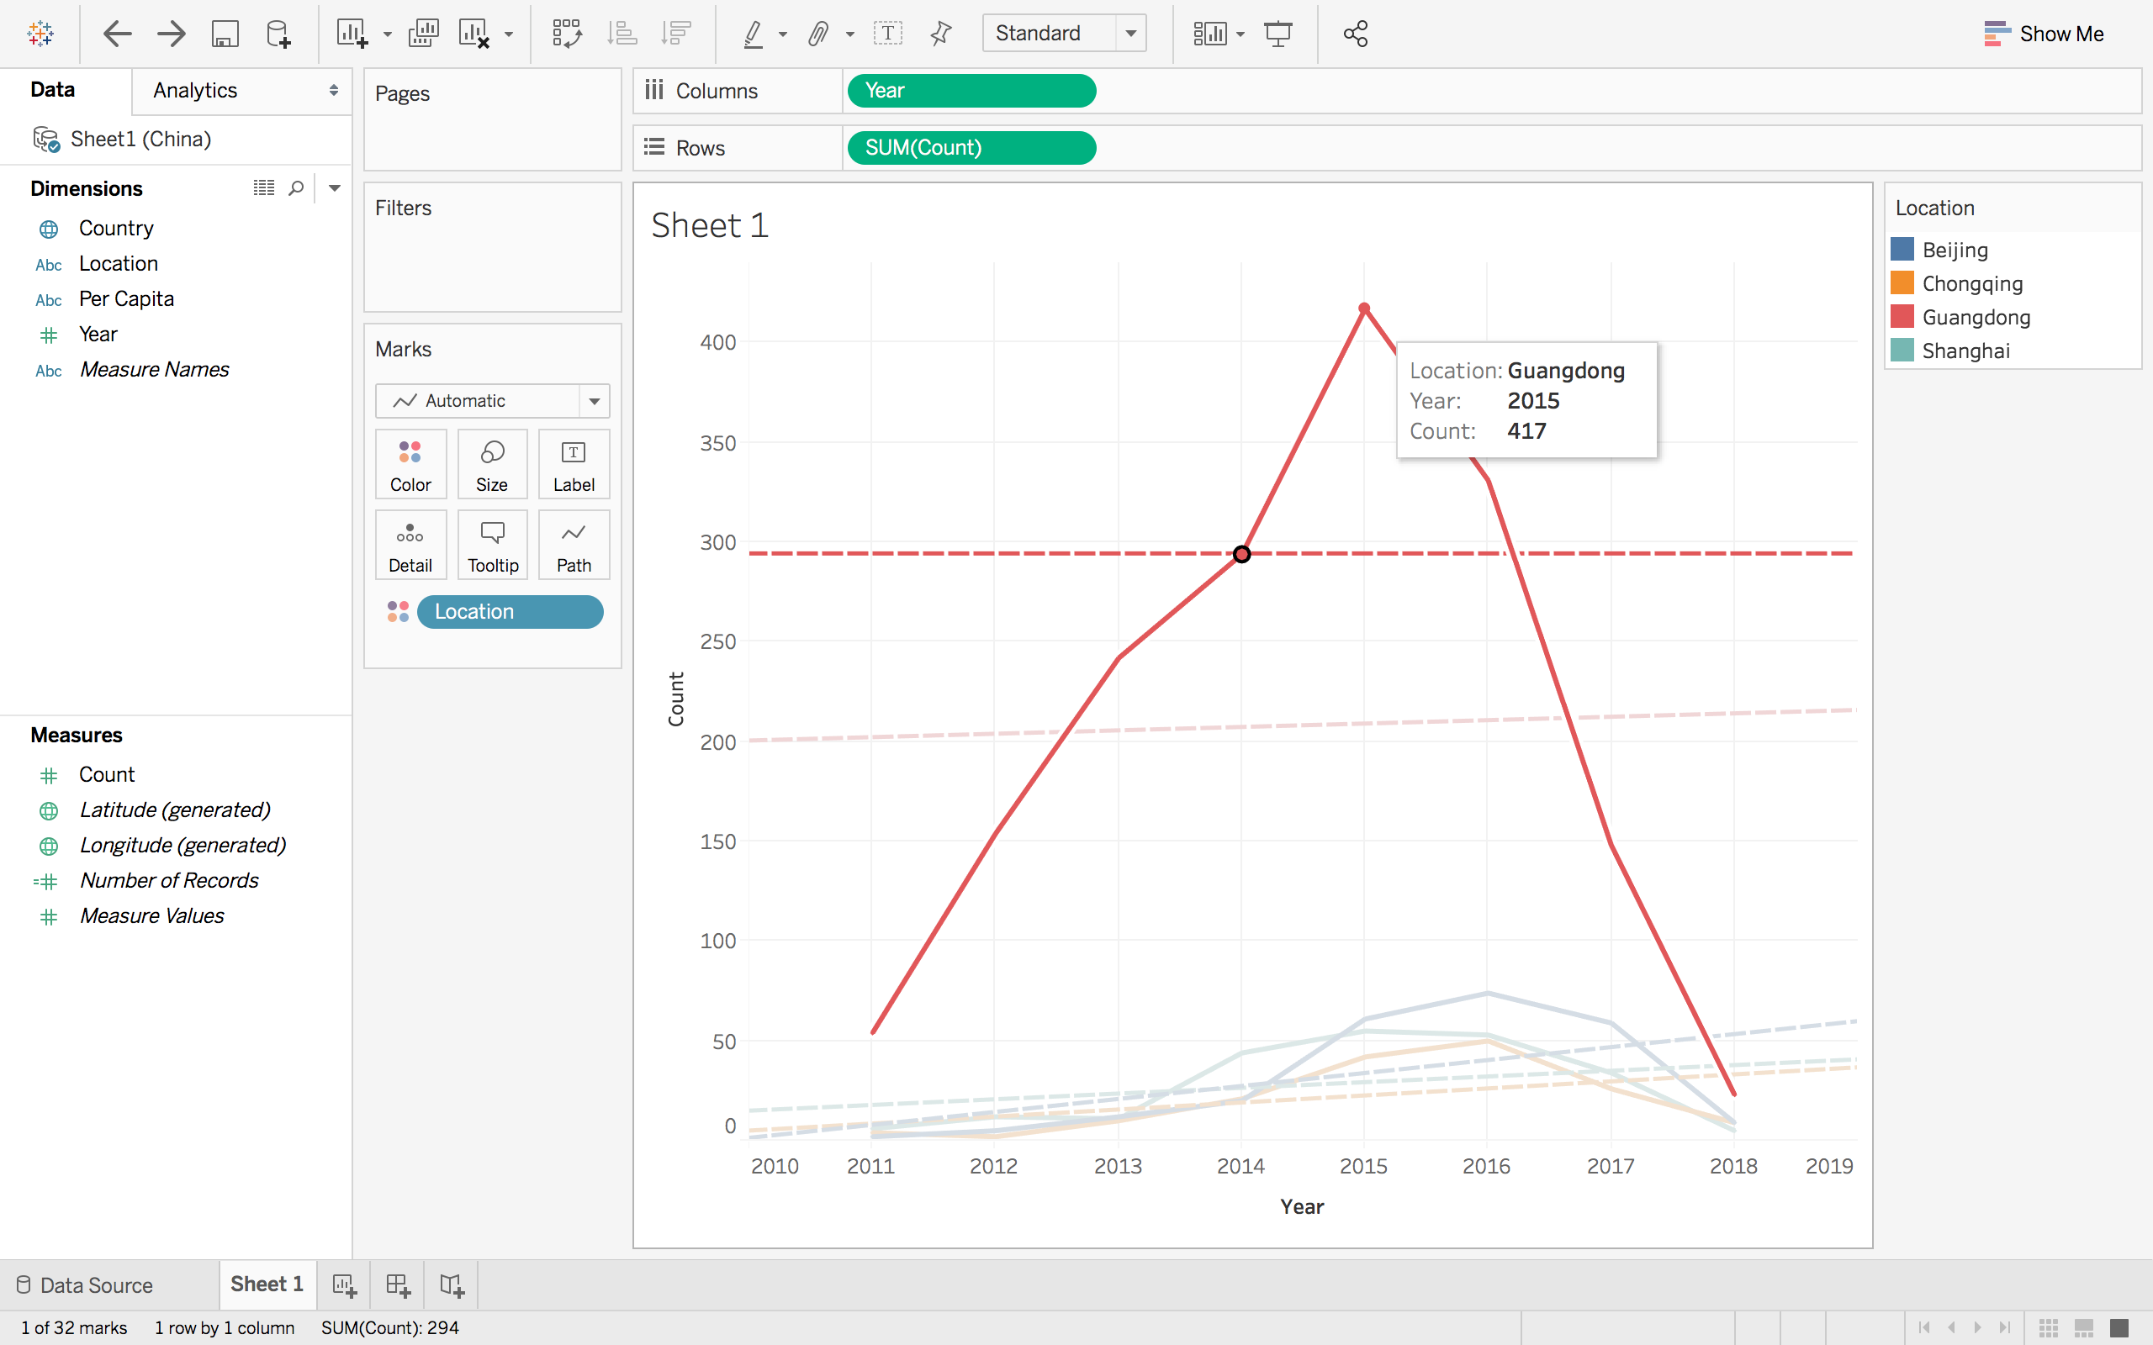

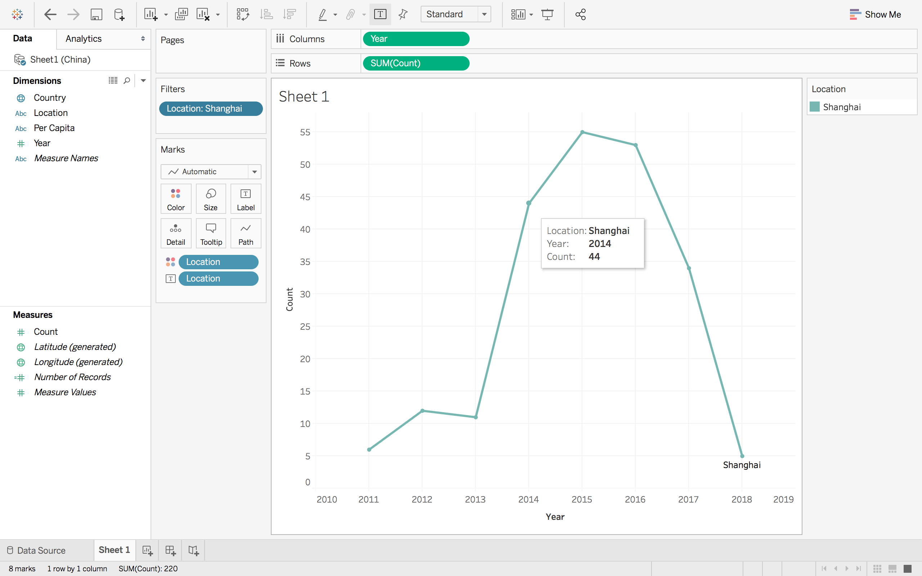

* Make one plot with all four locations on the same time plot in different colors. Use colorbrewer. (Use Tableau or R)

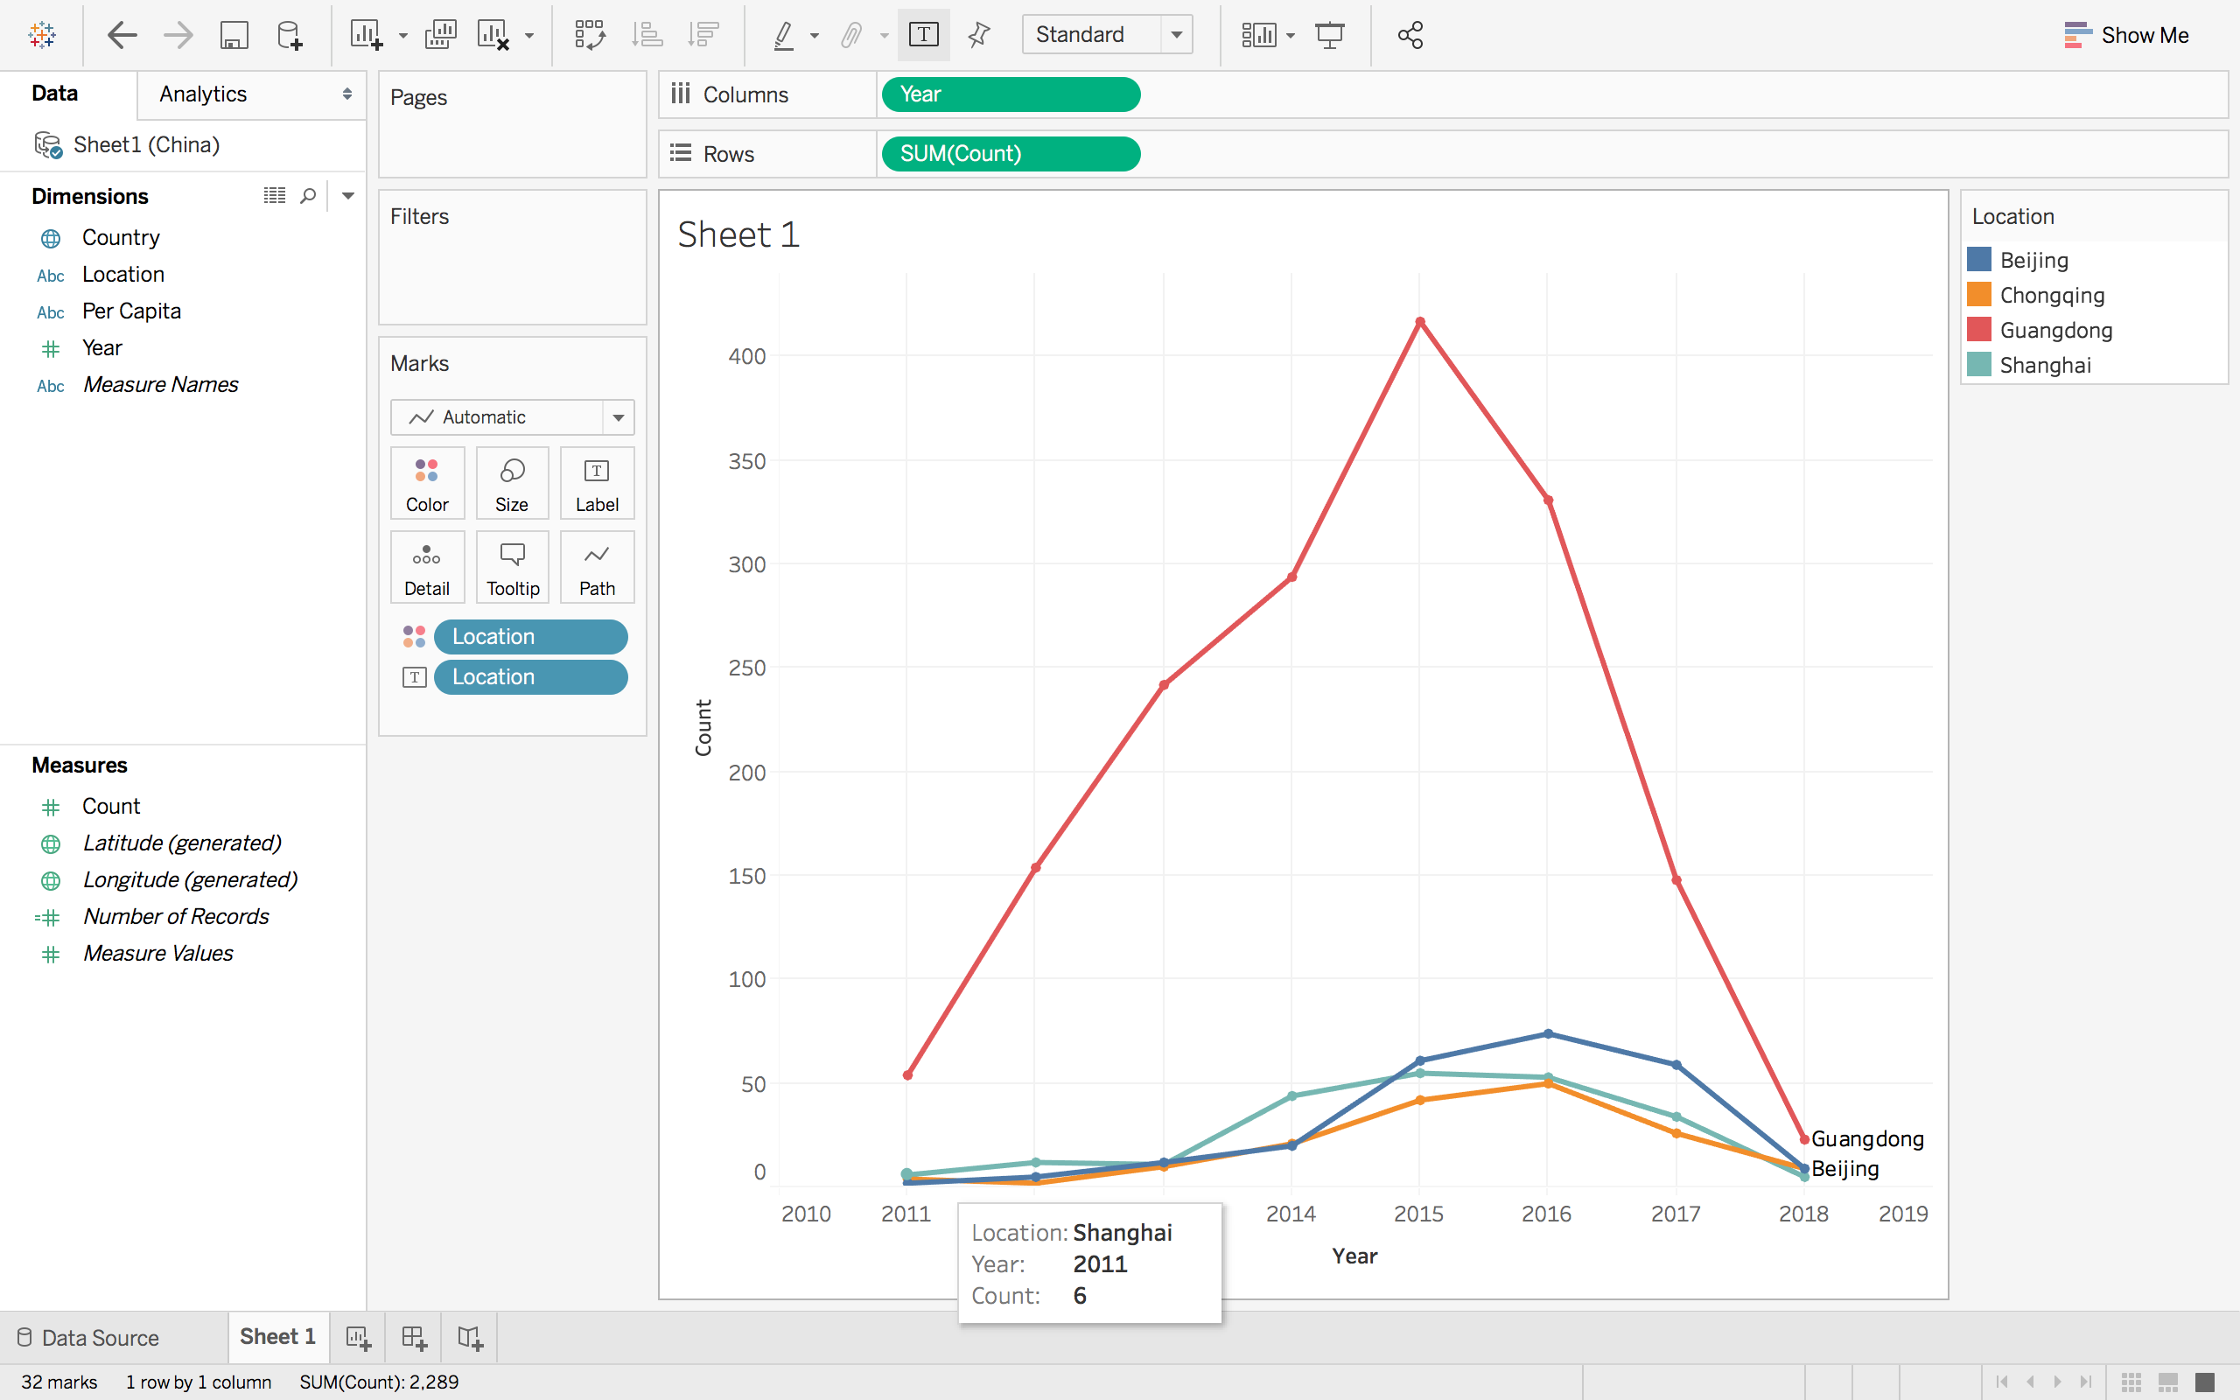

* Make a dynamic bubble graph using Tableau.

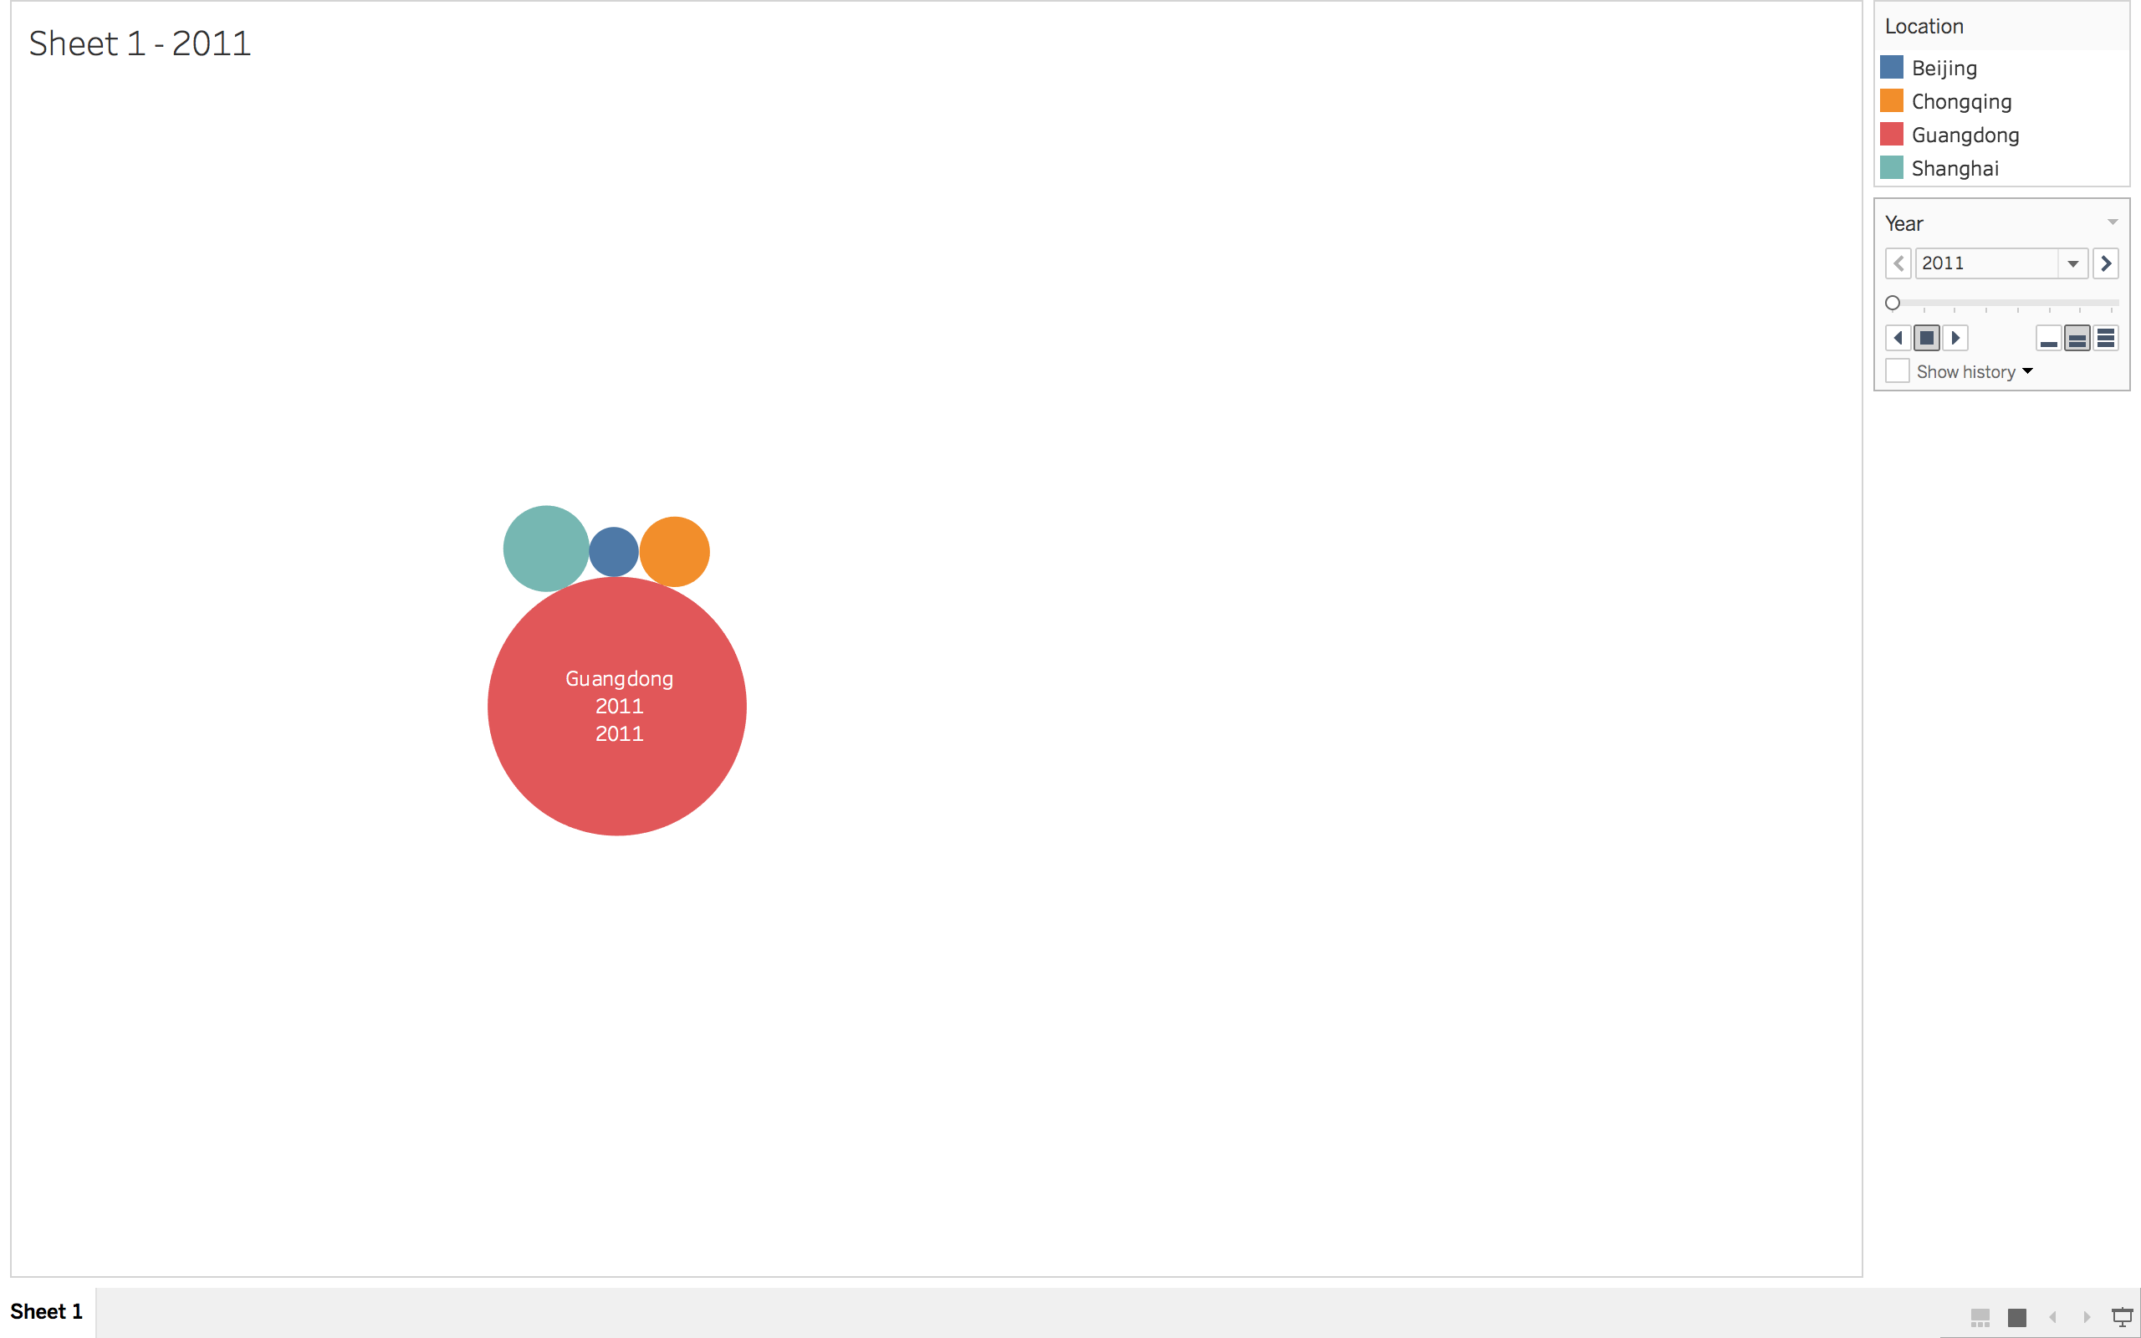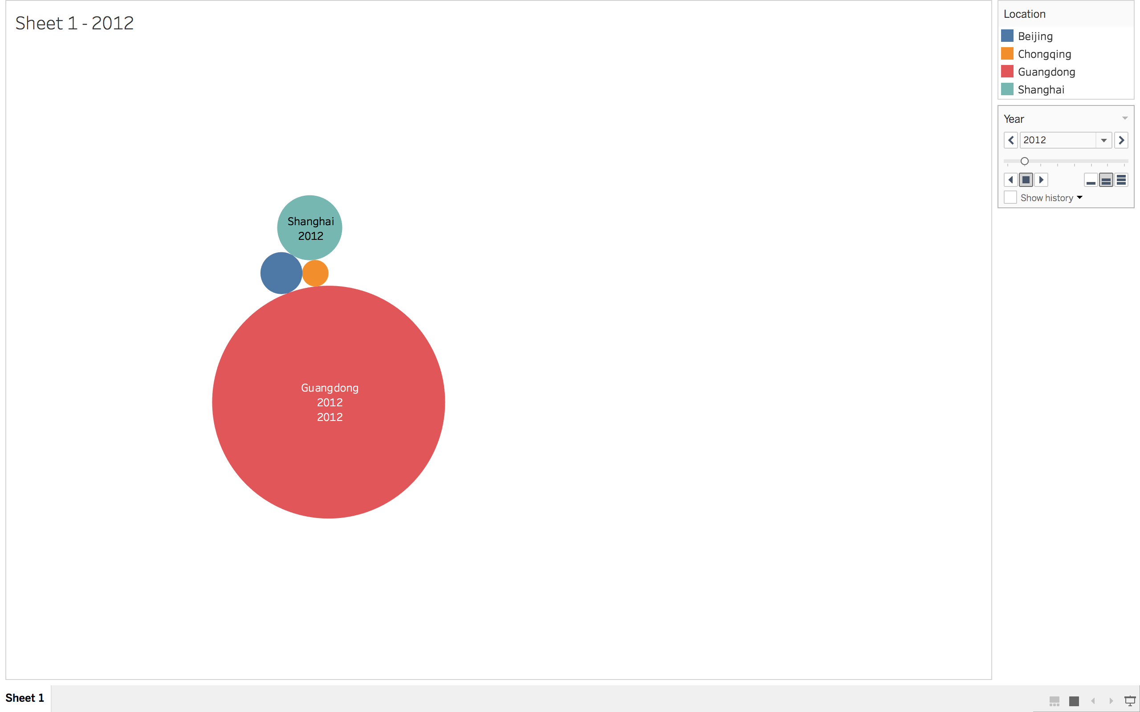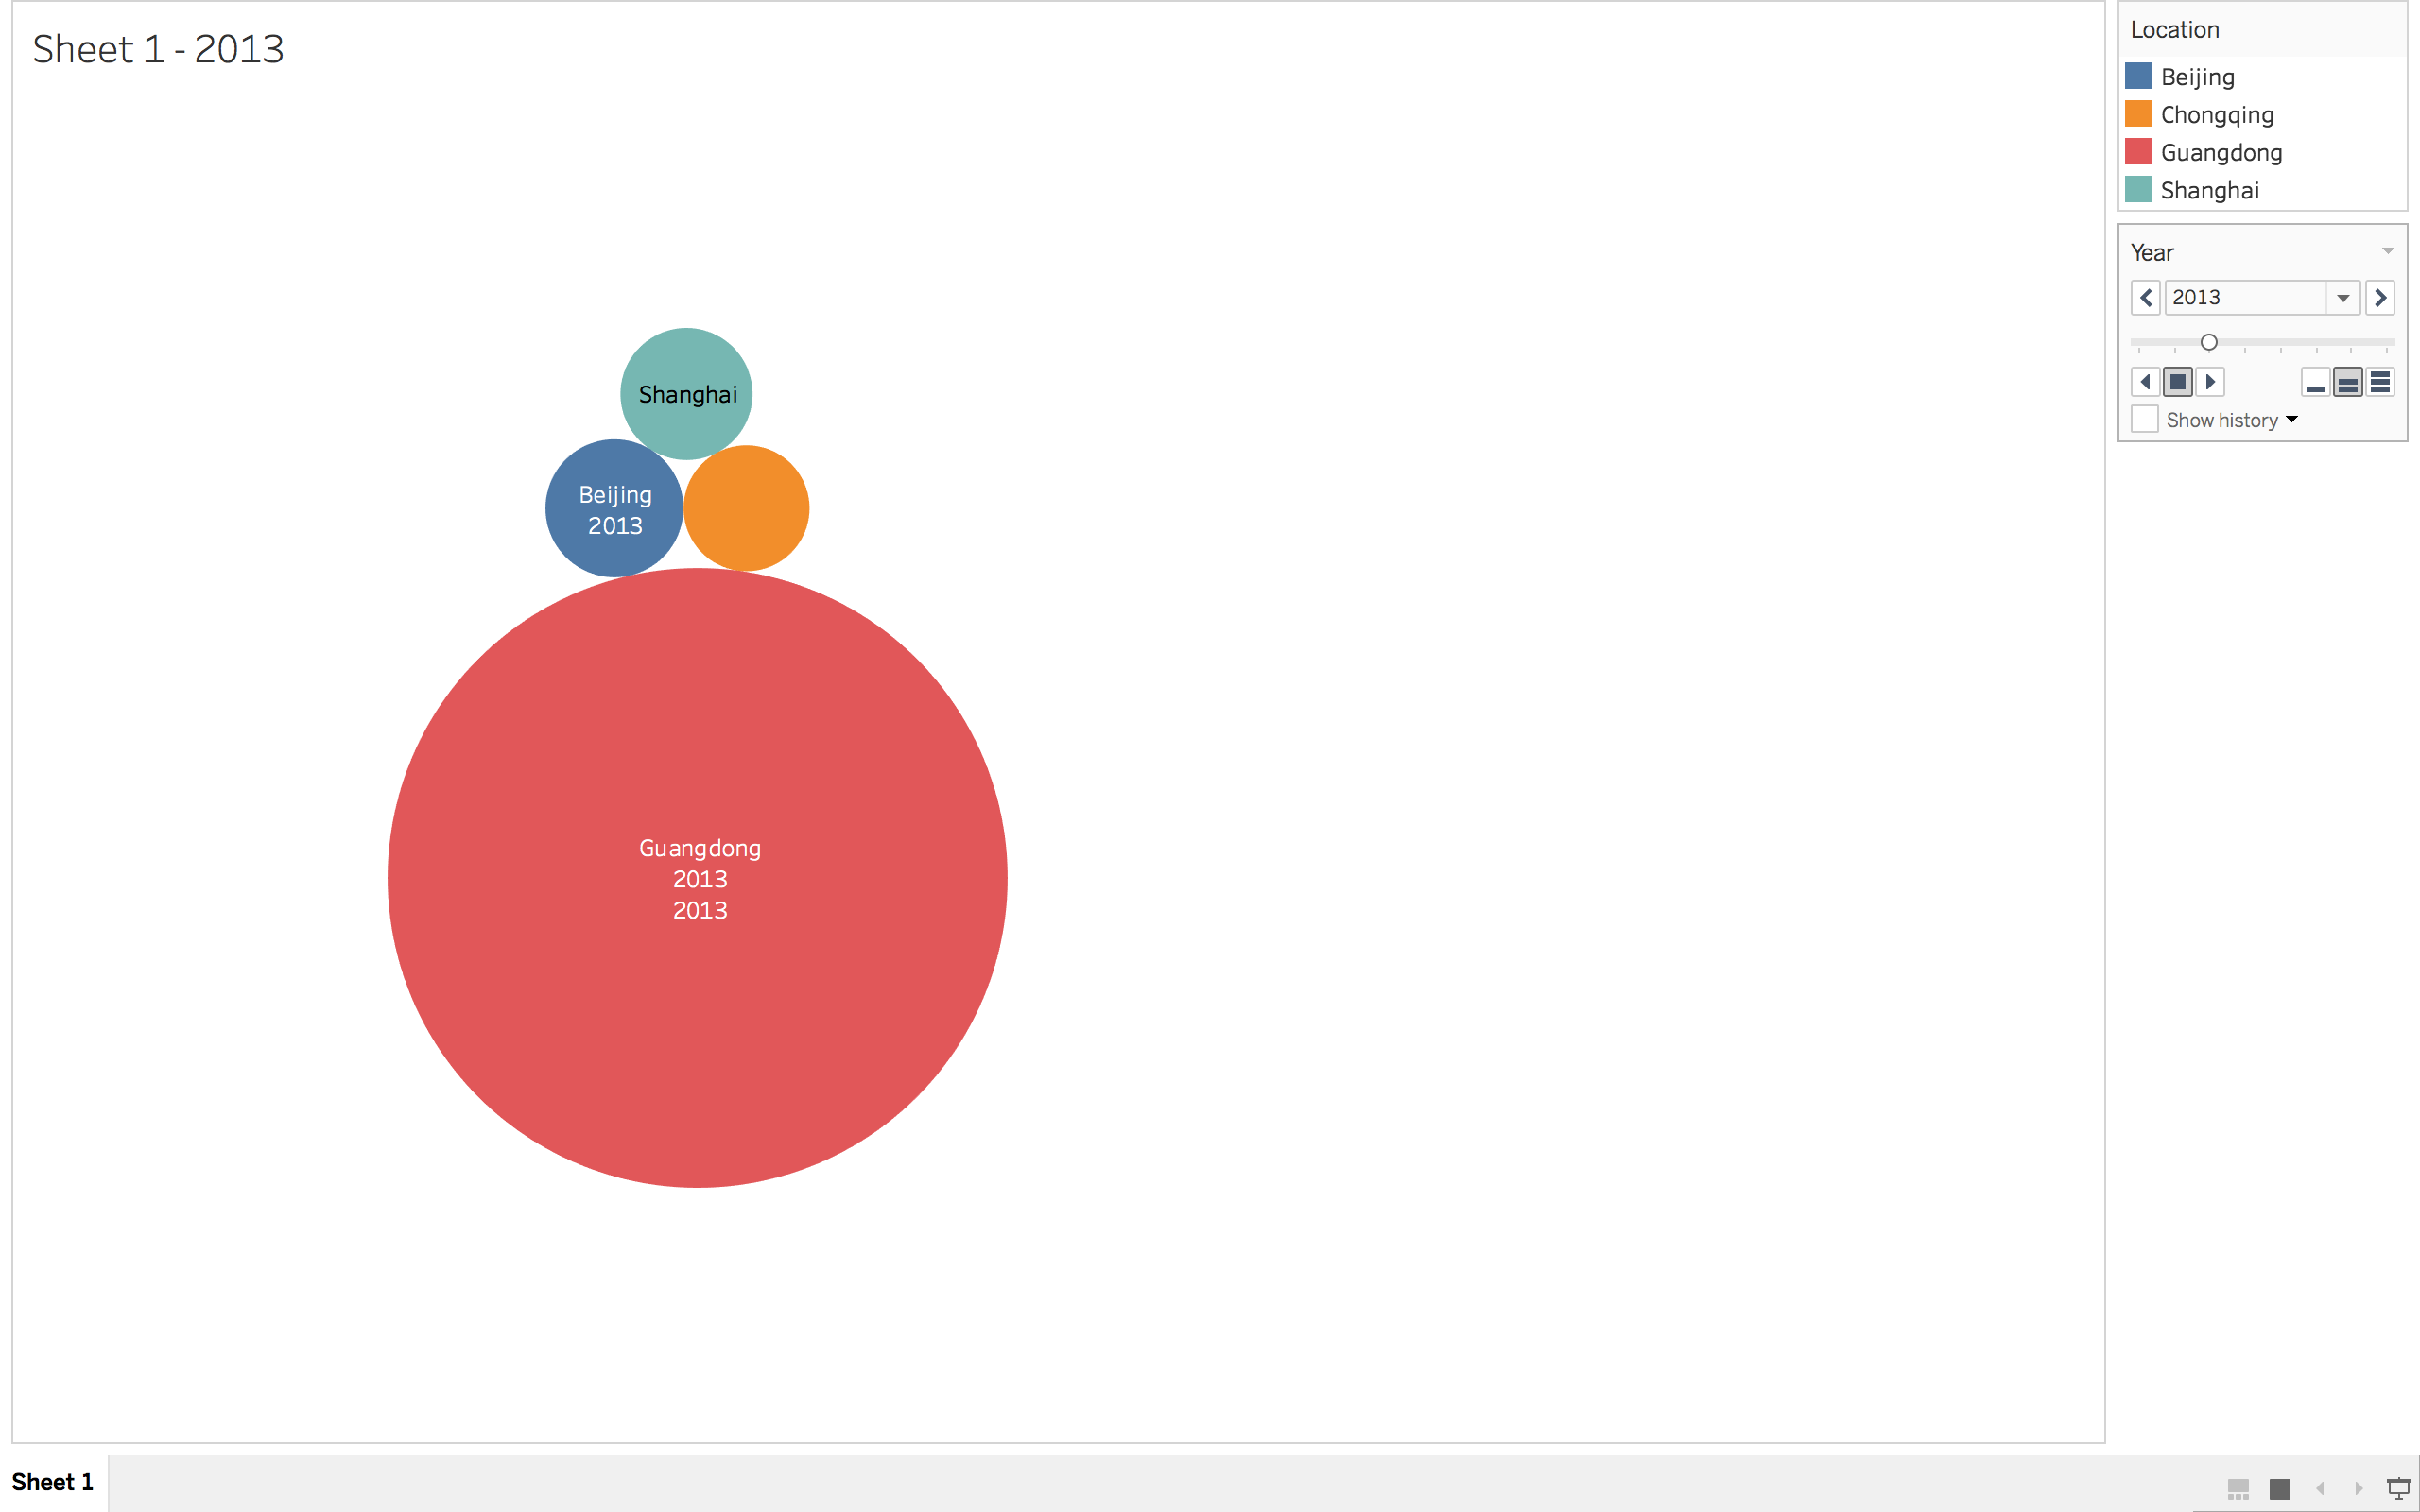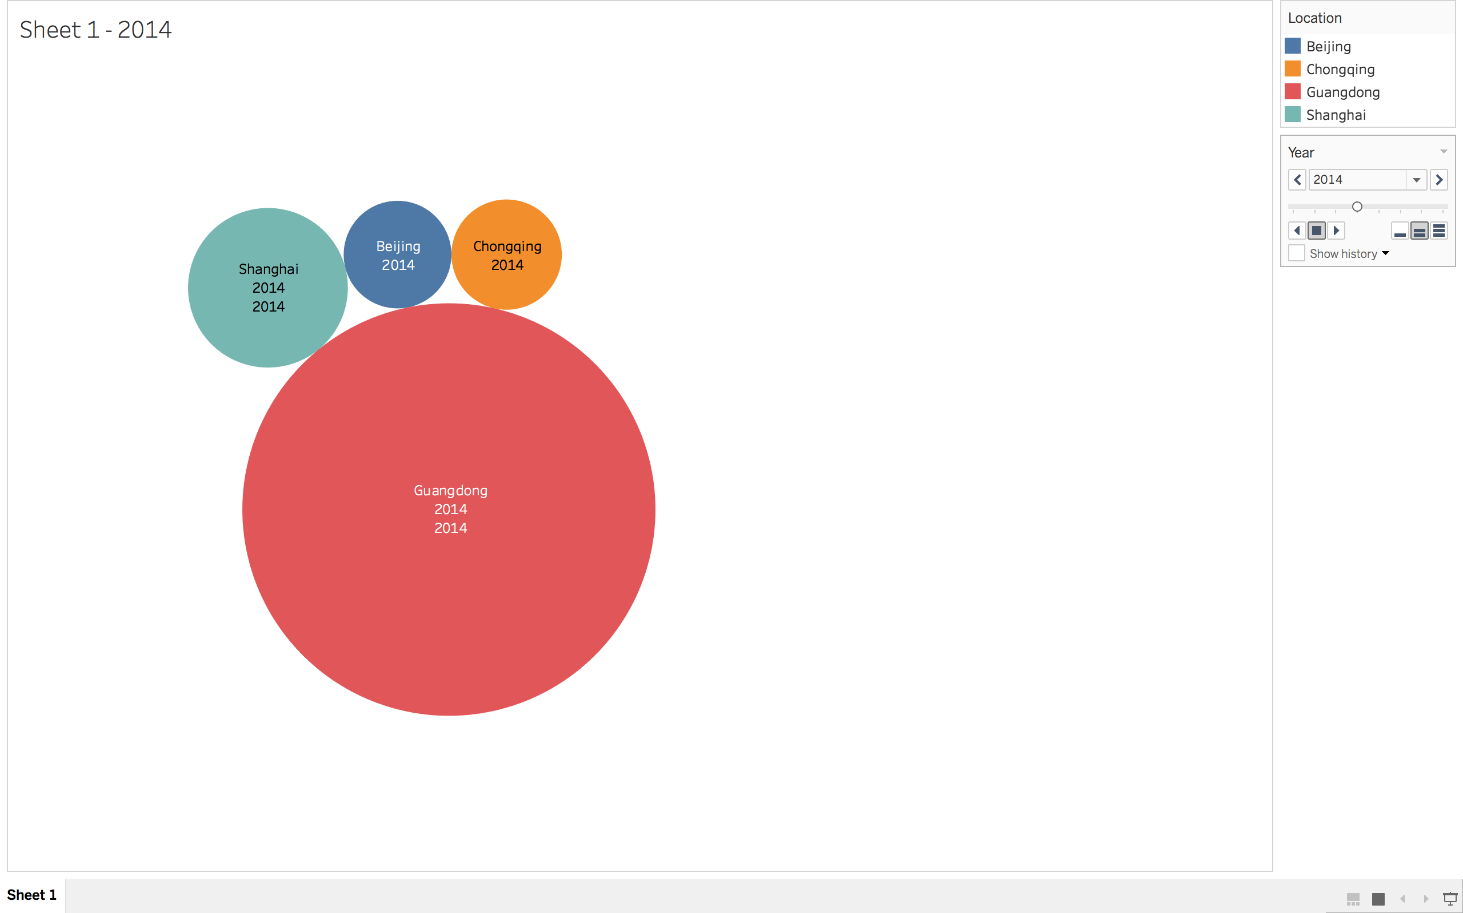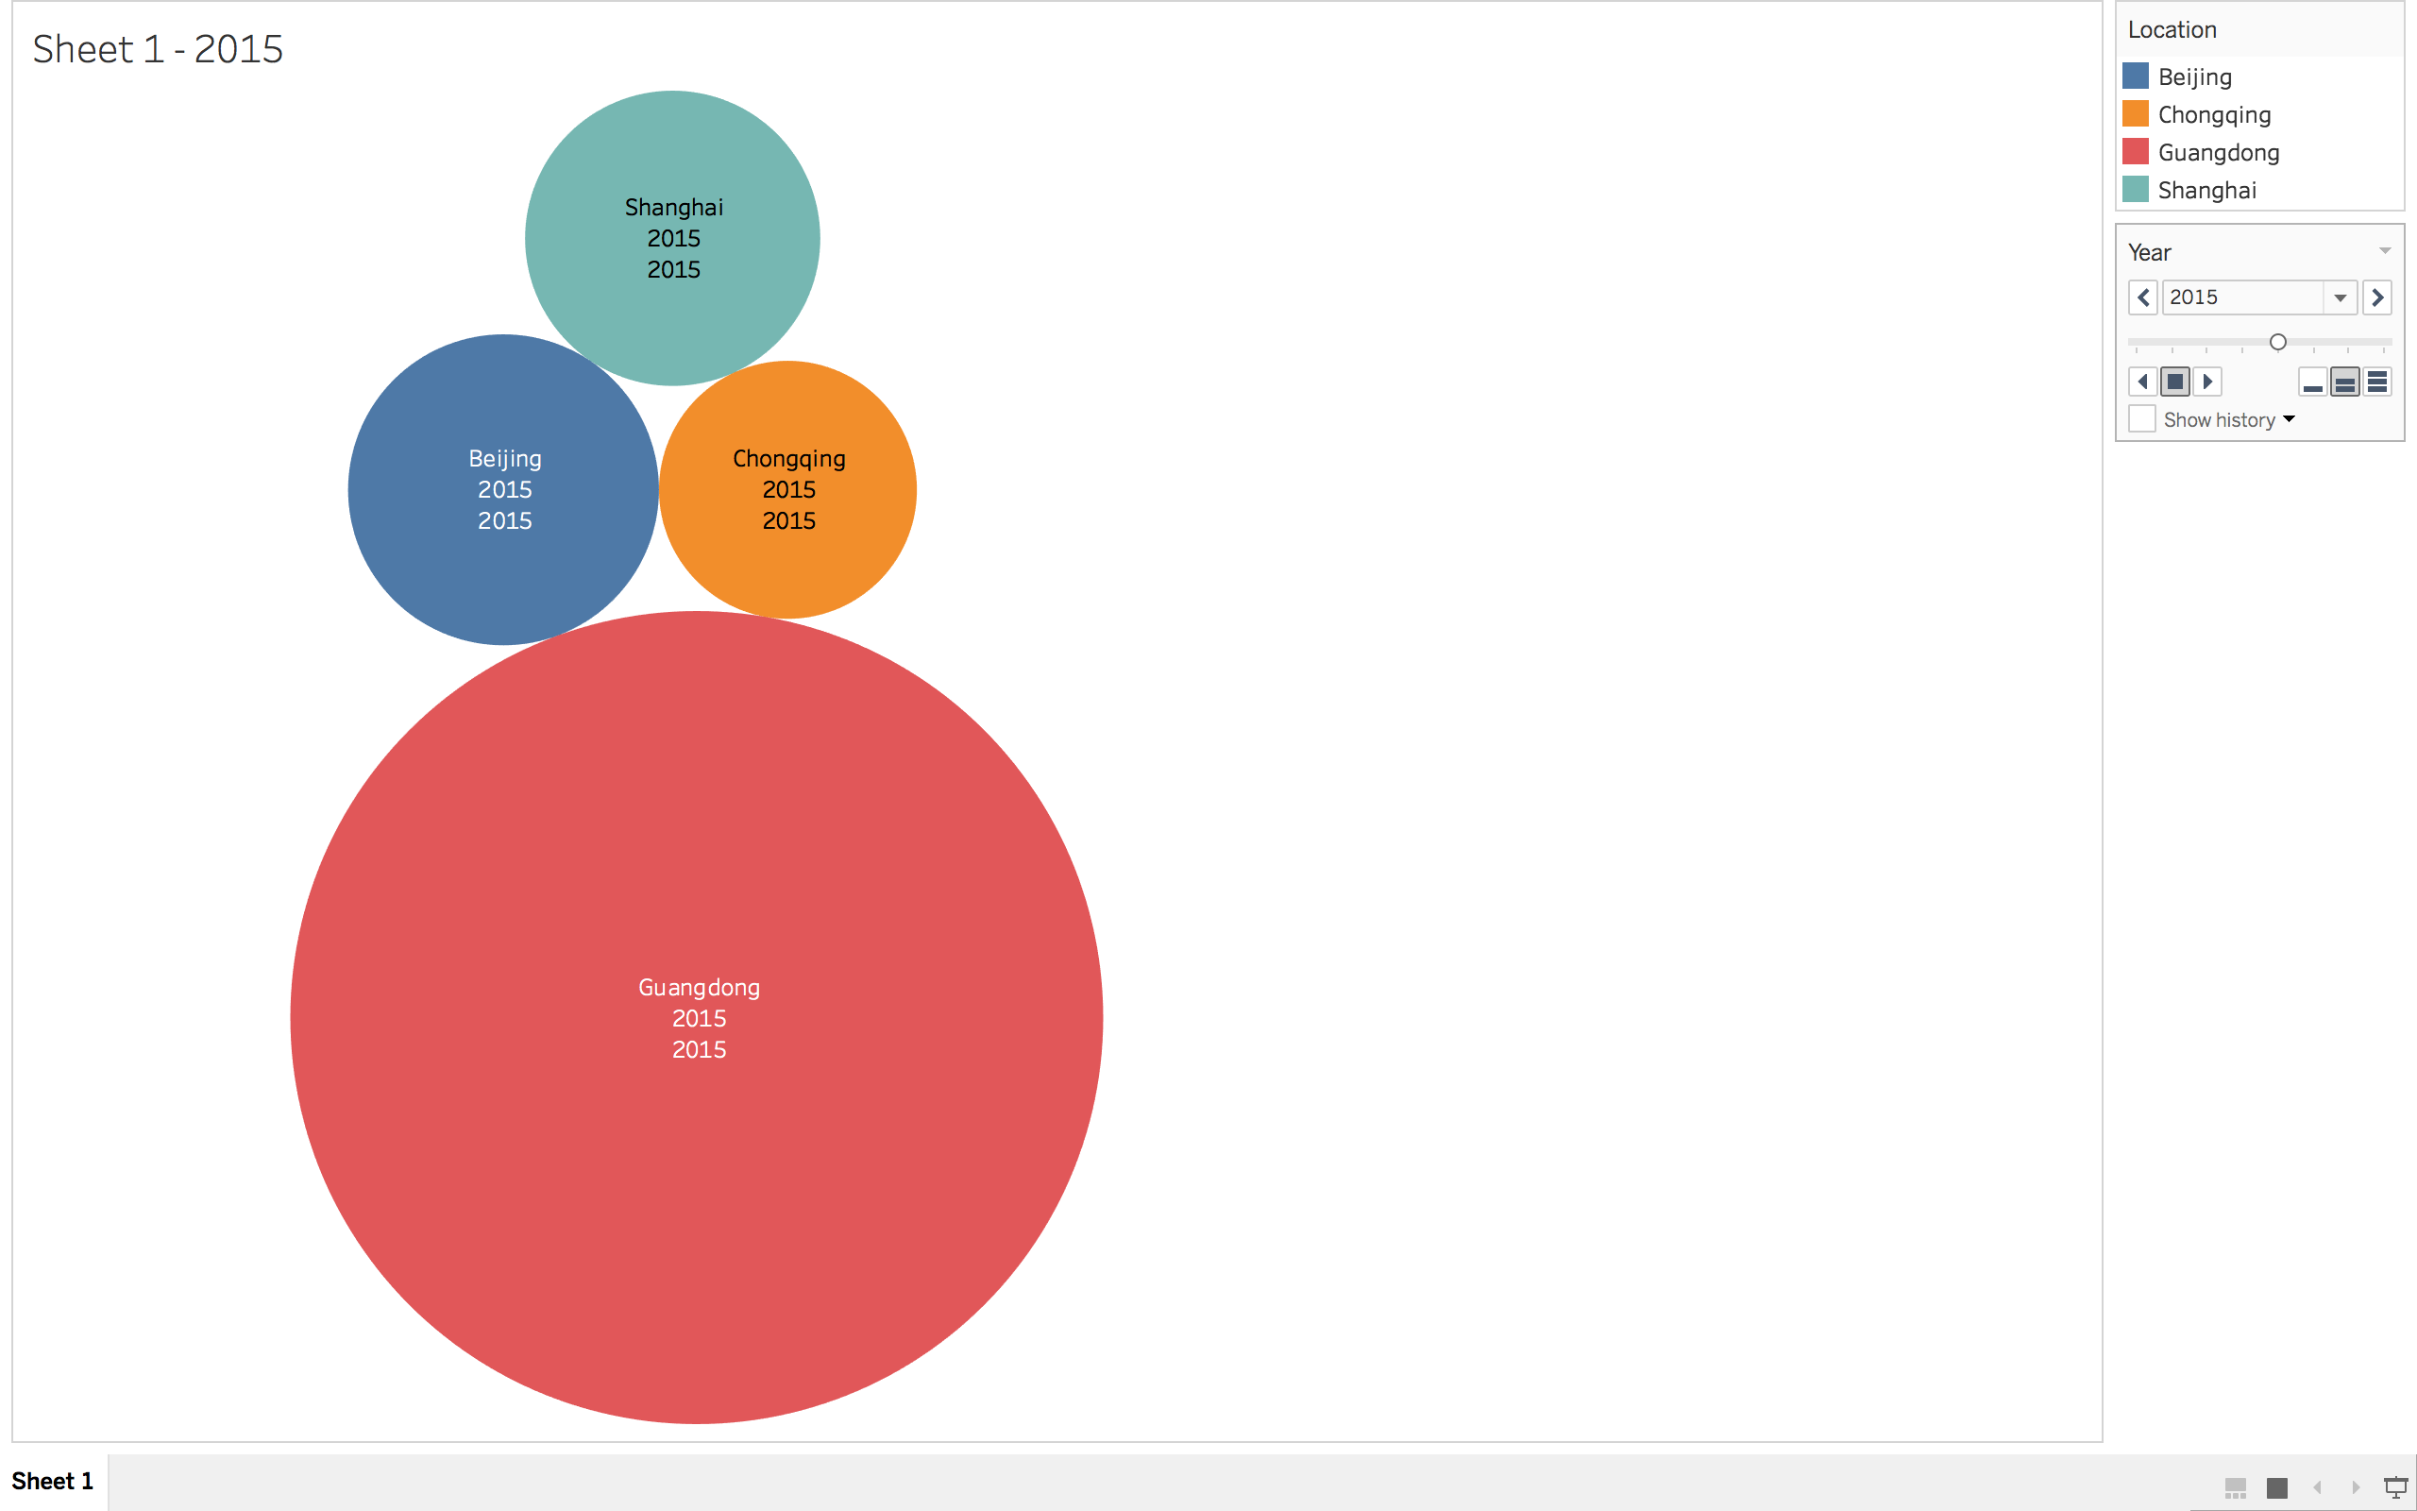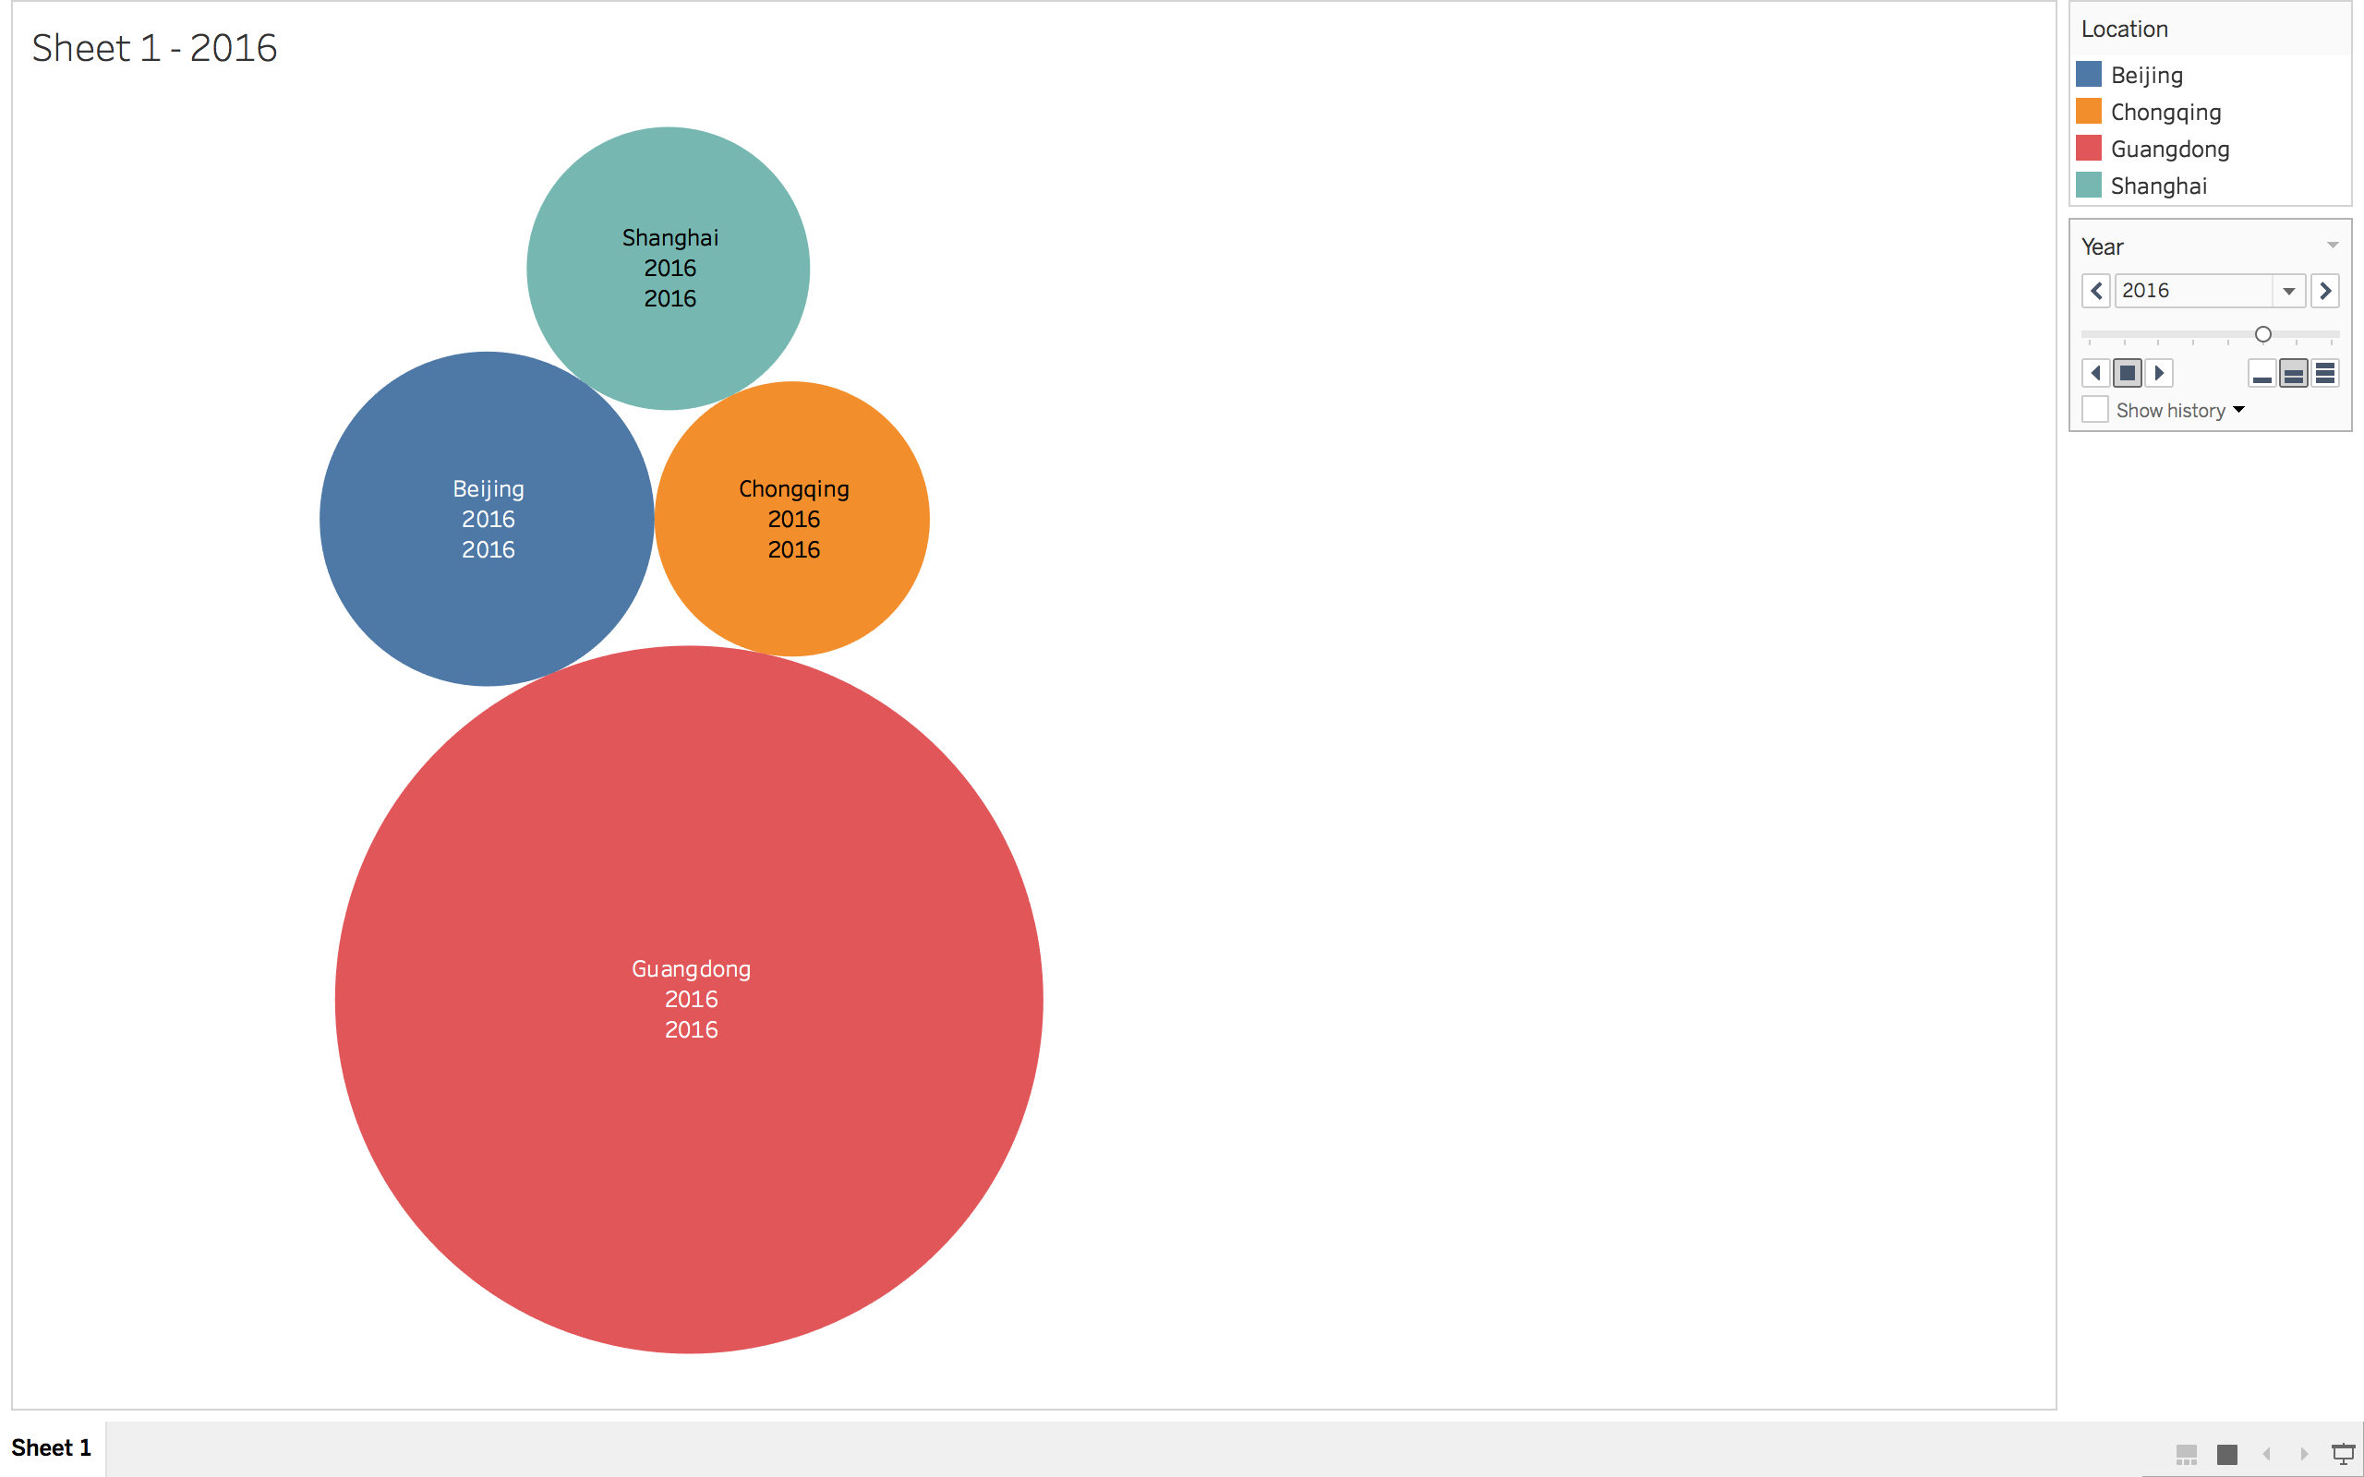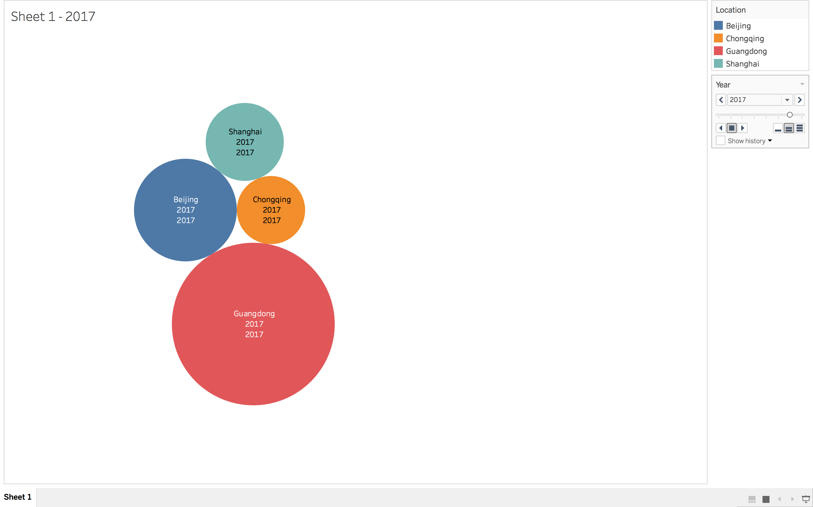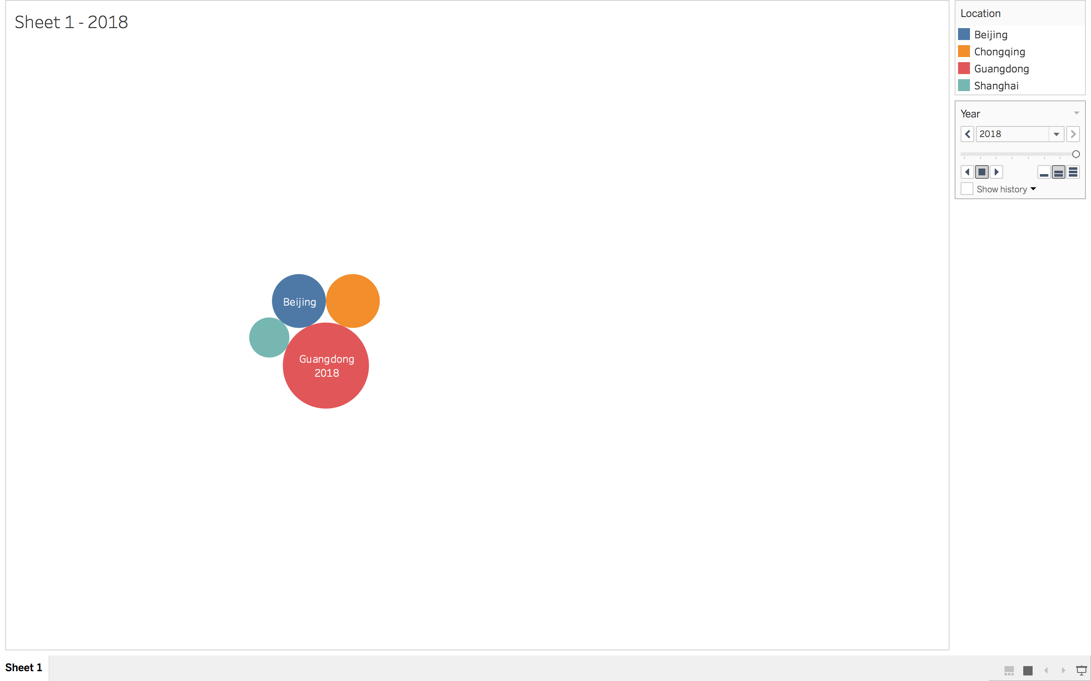

* What is a possible problem with the data selected for comparison? (Hint: Think about city populations size. See the [City Population](https://www.citypopulation.de/) website.)

Following table represents city population from year 2010 to 2016 in china. the data selected is not appropriate for comparison because the city population varies from one another at large scale. For example, Guangong’s population is more than 5 times higher than Beijing’s population. Working population ratio and hence, protest workers’ count in both the cities are incomparable.

|  |  |
| --- | --- |
| City | Population 2010-2016 in Millions |
| Beijing | 19.6 to 21.7 |
| Chongqing | 28.9 to 30.6 |
| Guangdong | 104 to 110 |
| Shanghai | 23 to 24 |

* Suggestions: For the dataset, include a Country variable/column, Tableau will be able to generate the Latitude and Longitude. So in the Excel spreadsheet include the variables Country, Location, Year, Count, Per Capita (last one is optional). When making the plot in Tableau, start by adding Country first to the Column shelf, then add Longitude and then add Latitude as the Row shelf. Lastly, Location is added as a Color and Count is added as a Size. Here is a link to an example of the [China_Labor map](https://public.tableau.com/profile/esuess#!/vizhome/China_Labor/Sheet3).

4. Try the code from [HelloFromCSUEastBay.Rmd](http://rpubs.com/esuess/HelloFromCSUEastBay1). Change the location and the popup. What is leafletjs? Show the plots you have created.

* [leafletjs](http://leafletjs.com/)
* [leaflet for R](https://rstudio.github.io/leaflet/)
* Alternatively, you could try [htmlwidgets](http://www.htmlwidgets.org/)
* **Leaflet** is a widely used [open source](https://en.wikipedia.org/wiki/Open-source_license) [JavaScript](https://en.wikipedia.org/wiki/JavaScript) [library](https://en.wikipedia.org/wiki/Library_(computing)) used to build [web mapping](https://en.wikipedia.org/wiki/Web_mapping) [applications](https://en.wikipedia.org/wiki/Application_software). First released in 2011,[[2]](https://en.wikipedia.org/wiki/Leaflet_(software)#cite_note-2) it supports most mobile and desktop platforms, supporting [HTML5](https://en.wikipedia.org/wiki/HTML5) and [CSS3](https://en.wikipedia.org/wiki/CSS3). Along with [OpenLayers](https://en.wikipedia.org/wiki/OpenLayers), and the [Google Maps API](https://en.wikipedia.org/wiki/Google_Maps_API), it is one of the most popular JavaScript mapping libraries and is used by major web sites such as [FourSquare](https://en.wikipedia.org/wiki/Foursquare), [Pinterest](https://en.wikipedia.org/wiki/Pinterest) and [Flickr](https://en.wikipedia.org/wiki/Flickr).
* Leaflet allows developers without a GIS background to very easily display [tiled web maps](https://en.wikipedia.org/wiki/Tiled_web_map) hosted on a public server, with optional tiled overlays. It can load feature data from [GeoJSON](https://en.wikipedia.org/wiki/GeoJSON) files, style it and create interactive layers, such as markers with popups when clicked.

Google Office

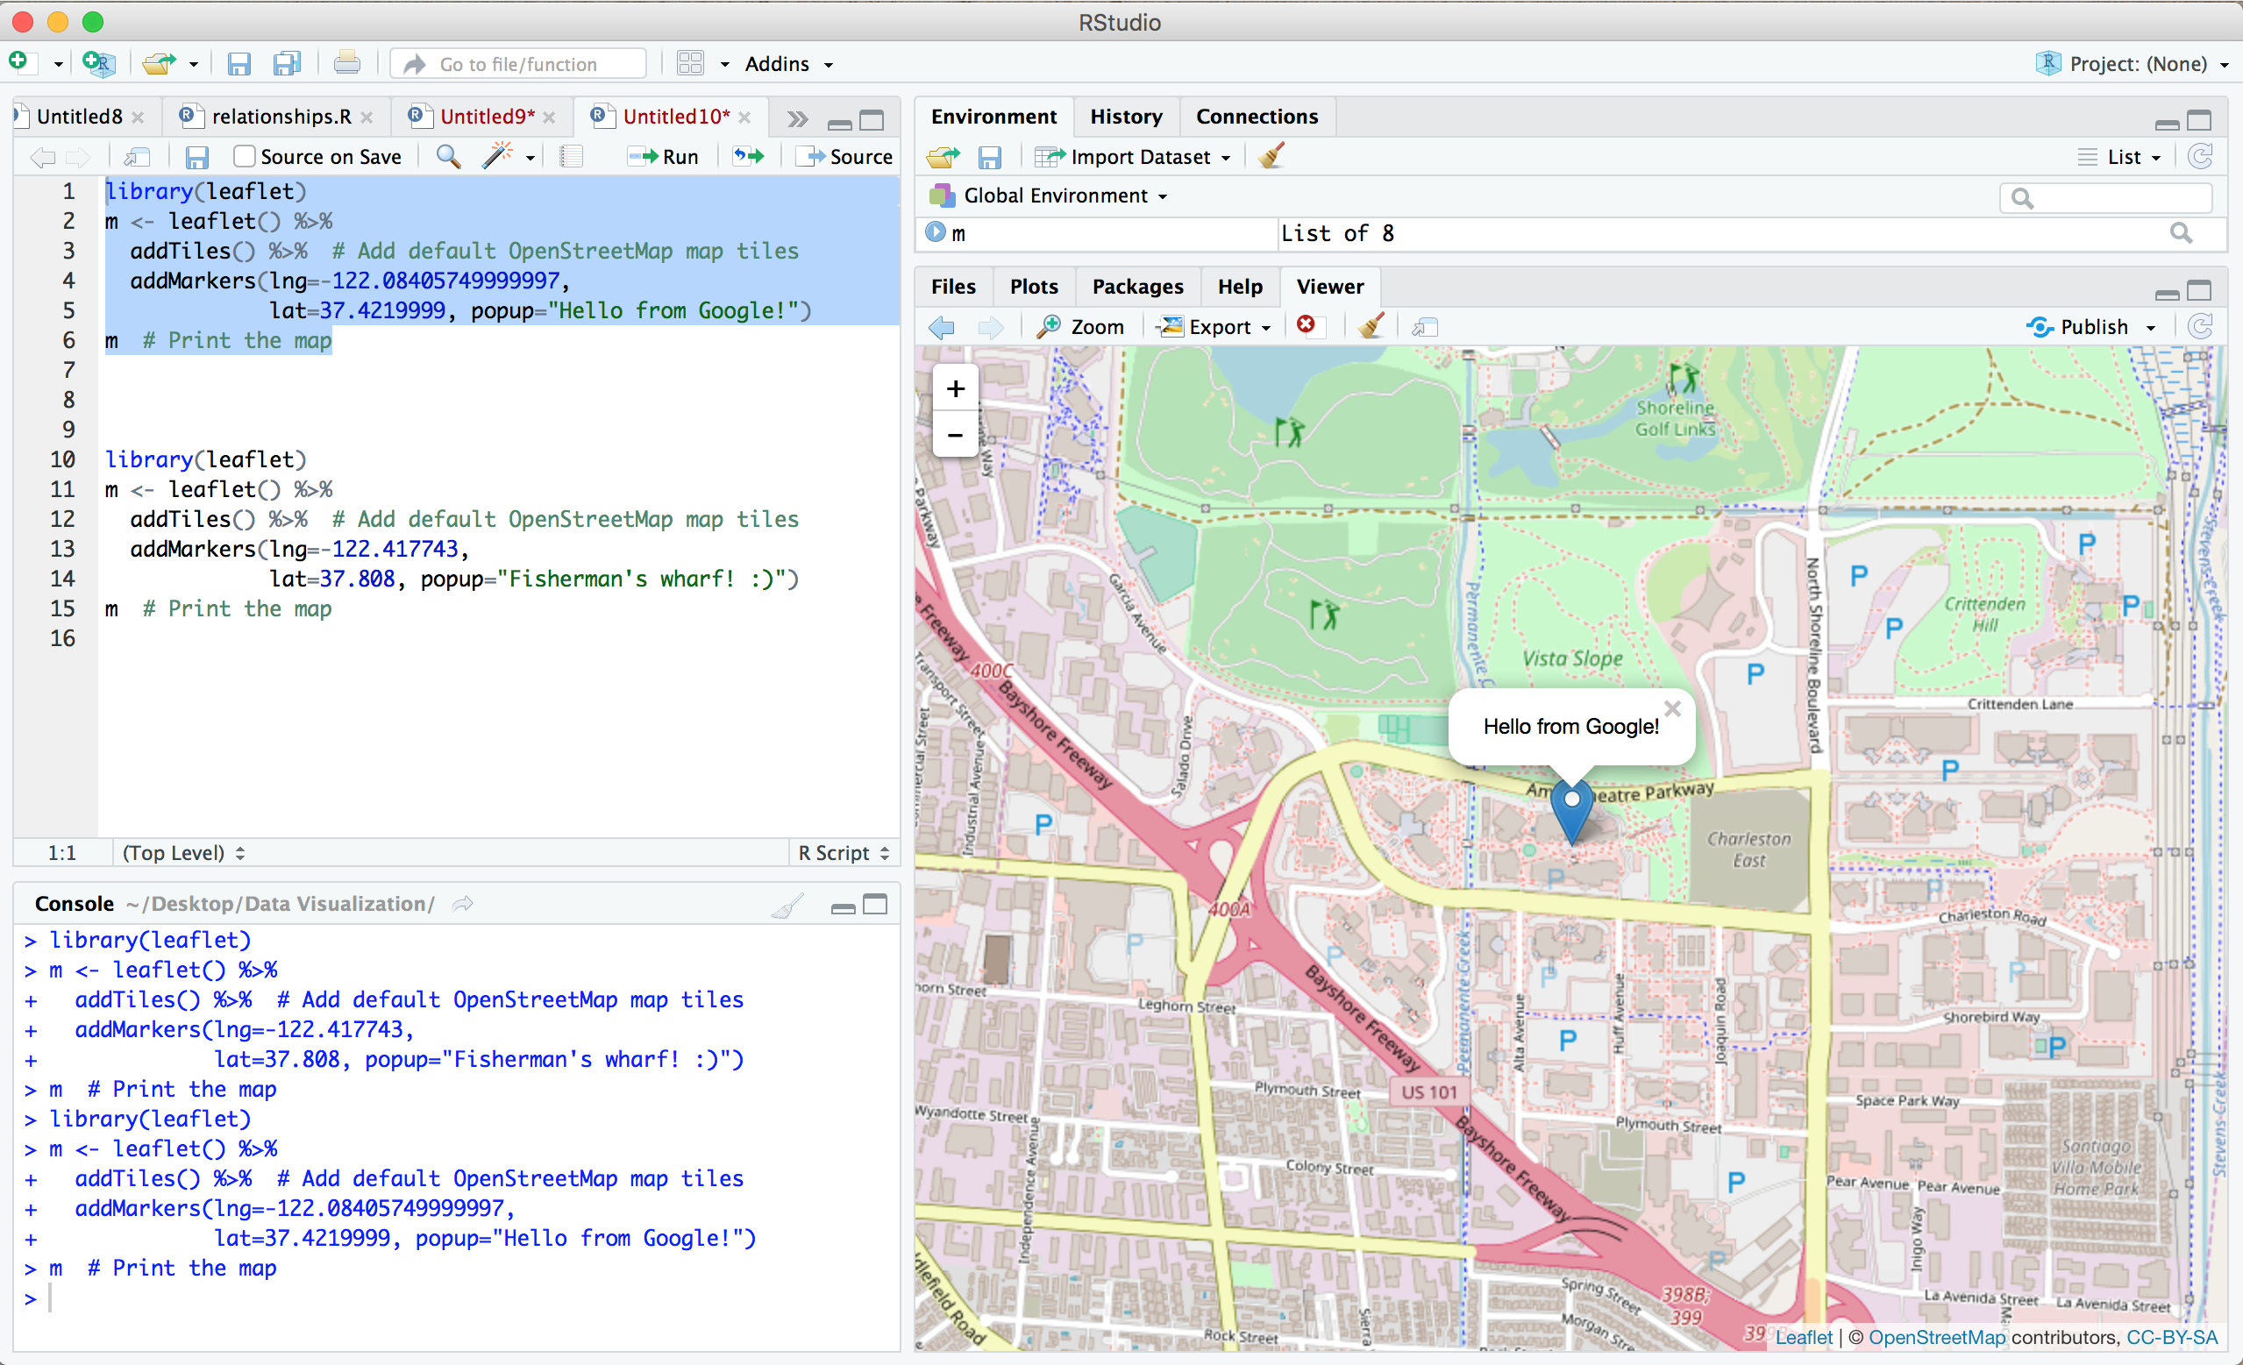

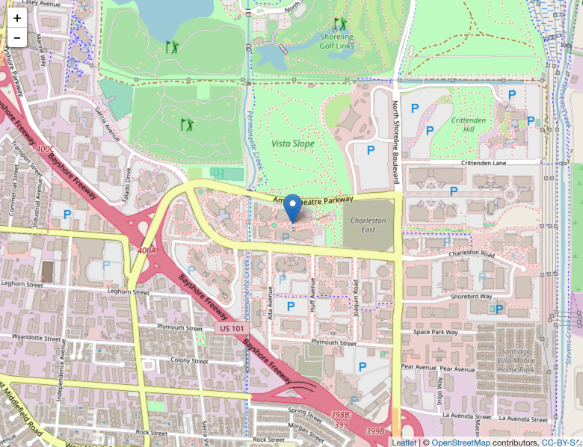

Fisherman’s Wharf

